

Mars Atmosphere and Volatile Evolution (MAVEN) Mission
Solar Wind Electron Analyzer (SWEA)

PDS Archive

Software Interface Specification

Rev. 2.6
SWEA
July 14, 2016

Prepared by

David L. Mitchell

mitchell@ssl.berkeley.edu
MAVEN
Solar Wind Electron Analyzer (SWEA)

PDS Archive
Software Interface Specification

Rev. 2.6 SWEA
July 14, 2016

Custodian:

David L. Mitchell Date
SWEA Principal Investigator

Approved:

Alexandria DeWolfe Date
MAVEN Science Data Center Lead

Raymond J. Walker Date
PDS PPI Node Manager

Thomas H. Morgan Date
PDS Project Manager
Contents
Introduction 9
1.1 Distribution List 9
1.2 Document Change Log 9
1.3 TBD Items 10
1.4 Abbreviations 10
1.5 Glossary 13
1.6 MAVEN Mission Overview 14
1.6.1 Mission Objectives 15
1.6.2 Payload 15
1.7 SIS Content Overview 16
1.8 Scope of this document 16
1.9 Applicable Documents 16
1.10 Audience 17
2 SWEA Instrument Description 18
2.1 Science Objectives 21
2.2 Instrument Operation 21
2.3 Measured Parameters 22
2.3.1 3D Distributions 23
2.3.2 Pitch Angle Distributions 24
2.3.3 Energy Spectra 25
2.4 Operational Modes 25
2.5 Operational Considerations 26
2.5.1 Spacecraft Charging and Photoelectrons 26
2.5.2 Field of View and Spacecraft Blockage 29
2.5.3 Energy-Dependent Field of View 29
2.6 Ground Calibration 29
2.6.1 Energy-Angle Response 29
2.6.2 Deflector Calibration 32
2.6.3 Analyzer Constant and Energy Resolution 33
2.6.4 Azimuthal Response and Field of View 35
2.7 In-flight Calibration 36
3 Data Overview 38
3.1 Data Processing Levels 38
3.2 Products 39
3.3 Product Organization 39
3.3.1 Collection and Basic Product Types 40
3.4 Bundle Products 41
3.5 Data Flow 41
4 Archive Generation 43
4.1 Data Processing and Production Pipeline 43
4.1.1 Raw Data Production Pipeline 43
4.1.2 Calibrated Data Production Pipeline 43
4.2 Data Validation 44
4.2.1 Instrument Team Validation 44
4.2.2 MAVEN Science Team Validation 44
4.2.3 PDS Peer Review 44
4.3 Data Transfer Methods and Delivery Schedule 46
4.4 Data Product and Archive Volume Size Estimates 47
4.5 Data Validation 47
4.6 Backups and duplicates 47
5 Archive organization and naming 49
5.1 Logical Identifiers 49
5.1.1 LID Formation 49
5.1.2 VID Formation 50
5.2 SWEA Archive Contents 50
5.2.1 SWEA Calibrated (MAVEN Level 2) Science Data Bundle 50
6 Archive product formats 61
6.1 Data File Formats 61
6.1.1 Calibrated data file structure 61
6.2 Document Product File Formats 65
6.3 PDS Labels 65
6.3.1 XML Documents 66
6.4 Delivery Package 66
6.4.1 The Package 66
6.4.2 Checksum Manifest 66
Appendix A Support staff and cognizant persons 67
Appendix B Naming conventions for MAVEN science data files 68
Appendix C Sample Bundle Product Label 70
Appendix D Sample Collection Product Label 73
Appendix E Sample Data Product Labels 77
Appendix F PDS Delivery Package Manifest File Record Structures 78
F.1 Transfer Package Directory Structure 78
F.2 MD5 Checksum Manifest Record Structure 78
Appendix G PDS4 Labels for SWEA CDF Data Files 79
G.1. CDF Formatted Data Files 79
G.2. CDF and PDS4 Metadata 79
G.2.1. PDS4 Label Structure 79
G.2.1.1. PDS Label Physical Structure Description 79
G.2.1.2. Parameter Logical Relationships 81
G.2.1.3. Constant Values 83

List of Figures
Figure 1: The MAVEN SWEA instrument (left) and analyzer cross-section schematic (above). Azimuth is measured about the instrument’s symmetry axis (vertical dashed line). Elevation is measured with respect to the instrument’s aperture plane (horizontal dashed line). ………………………………………………………………………………………..18
Figure 2a: SWEA is on the end of a 1.5-meter boom, with its symmetry axis (Z_{SWEA}) aligned with the spacecraft Z axis (Z_{PL}). SWEA has a 360° × 120° field of view (blue shading indicates the instrument's blind spots). When the spacecraft Z_{PL} axis points to the Sun, the SWEA electronics box shields the analyzer (including the toroidal entrance grids) from sunlight. This eliminates photoelectron production from the toroidal grids and within the aperture. ……………………………………………………………………………………20
Figure 2b: SWEA coordinates are defined with respect to aperture plane and the anode layout, with the X axis at the boundary between anodes 15 and 0. To transform between spacecraft and SWEA coordinates, rotate about the Z axis by 140 degrees. Azimuth (ϕ) and elevation (θ) are defined with respect to SWEA coordinates. Red segments indicate the locations of support ribs for the toroidal grids (see also Fig. 12). ………………………………………20
Figure 3: Sweep pattern for the analyzer and deflector voltages. When enabled, V0 (not shown) is scaled to the analyzer voltage up to a maximum value of −25 V. Vertical dotted lines are at ~15 millisec intervals. Voltages are not to scale. 22
Figure 4: Charging of the Geotail spacecraft in sunlight. (Ishisaka et al., 2001). The curve for MAVEN has not yet been measured but is expected to be similar. 27
Figure 5: Electron density profiles in Mars’ ionosphere away from crustal magnetospheres for solar minimum and maximum conditions (after Fox 2004). 28
Figure 6: Measured energy-angle response, normalized to unity, at a mechanical yaw of 0 deg (top left). Theta is the deflection angle achieved by varying the deflector voltages (see Fig. 9), and K is ratio of the beam energy (Ebeam) to the analyzer voltage (Va). In this calibration run, the beam energy was held constant while the analyzer voltage was varied. The line drawings are the integrated responses, renormalized to unity, in angle (upper right) and energy (lower left). The simulation (lower right) has been shifted by ΔK = −0.44 (see text). 30
Figure 7: Measured energy-angle response (top left and both line drawings) and simulated response (lower right) for a yaw of −45°. In the simulation, K is shifted by the same amount as for zero yaw. See caption to Fig. 6. 31
Figure 8: Measured energy-angle response (top left and both line drawings) and simulated response (lower right) for a yaw of +45°. In the simulation, K is shifted by the same amount as for zero yaw. See caption to Fig. 6. 32
Figure 9: Mechanical yaw as a function of V_{D}/V_{A}. Diamond symbols are the measured values, and the red line is a linear fit to those measurements. The blue dashed line is derived from detector simulations. 33
Figure 10: Energy response obtained by integrating the measured energy-angle response function at a yaw of zero (Figure 6). The weighted mean value of K and the energy width (ΔE/E, FWHM) are indicated. 34
Figure 11: Analyzer constant (K_{a}) as a function of azimuth around the FOV. The red line is the best fit sine function. 34
Figure 12: Detector response as a function of azimuth around the field of view at yaw=0. The responses of all 16 anodes (numbered 0 through 15) are shown. Vertical dashed lines indicate the locations of support ribs for the toroidal grids. 36
Figure 13: A graphical depiction of the relationship among bundles, collections, and basic products. 40
Figure 14: MAVEN Ground Data System responsibilities and data flow. Note that this figure includes portions of the MAVEN GDS which are not directly connected with archiving, and are therefore not described in Section 3.5 above. 42
Figure 15: Duplication and dissemination of SWEA archive products at PDS/PPI. 48
Figure 16: SWEA 3D data product showing the angular distribution of 125-eV electrons in the solar wind. The data are normalized to unity at the peak energy flux, and relative variations are shown with a linear color scale. The data are mapped in SWEA science coordinates over the full sky with an Aitoff projection, and each azimuth-elevation bin is labeled with its bin number (0-95). The instrument's blind spots (|elevation| > 60°) and bins blocked by the spacecraft have no color. The magnetic field direction is indicated by the plus (+B) and diamond (−B) symbols. 53
Figure 17: Electron pitch angle distribution measured in the solar wind over the same time interval in Fig. 16. The distribution is measured twice (blue and red), and the pitch angle coverage of each bin is indicated by the horizontal bar. This cut through the 3D distribution does not intersect the spacecraft, so all 16 pitch angle bins represent valid measurements. When a cut does include 3D bins that are blocked by the spacecraft, those bins are flagged as invalid in the PAD data. 56
Figure 18: Electron energy distribution measured in the solar wind. The 64 energy channels are logarithmically spaced from 3 eV to 4.6 keV, with a sampling in energy (12%) that is finer than the instrument's intrinsic energy resolution of 17% (ΔE/E, FWHM) The vertical dashed line is an estimate of the spacecraft potential (see text). ………………………….. 58

List of Tables
Table 1: Distribution list 9
Table 2: Document change log 9
Table 3: List of TBD items 10
Table 4: Abbreviations and their meaning 10
Table 5: 19-to-8 Compression 23
Table 6: Analyzer constant and energy resolution as a function of mechanical yaw with respect to the beam direction. 35
Table 7: MAVEN SWEA Archive Schema and Schematron 38
Table 8: Data processing level designations 38
Table 9: Collection product types 41
Table 10: SWEA Bundle 41
Table 11: MAVEN PDS review schedule 45
Table 12: Archive bundle delivery schedule 46
Table 13: swea.calibrated Level 2 Science Data Collections 50
Table 14: SWEA Calibrated Science Data Documents 60
Table 15: Contents for swea.calibrated.svy_3d and swea.calibrated.arc_3d data files 61
Table 16: Contents for swea.calibrated.svy_pad and swea.calibrated.arc_pad data files 63
Table 17: Contents for swea.calibrated.svy_spec and swea.calibrated.arc_spec data files 64
Table 18: Archive support staff 67
Table 19: File naming convention code descriptions. 68
Table 20: File naming convention instrument codes. 69

Introduction
This software interface specification (SIS) describes the format and content of the Solar Wind Electron Analyzer (SWEA) Planetary Data System (PDS) data archive. It includes descriptions of the data products and associated metadata, and the archive format, content, and generation pipeline.

Distribution List
Table 1: Distribution list
Name | Organization | Email
David L. Mitchell | UCB/SSL | mitchell@ssl.berkeley.edu
Alexandria DeWolfe | LASP/SDC | alex.dewolfe@lasp.colorado.edu
Steve Joy | UCLA/PDS/PPI | sjoy@igpp.ucla.edu
Ray Walker | UCLA/PDS/PPI | rwalker@igpp.ucla.edu
Joe Mafi | UCLA/PDS/PPI | jmafi@igpp.ucla.edu
Reta Beebe | NMSU/PDS/Atmospheres
Lyle Huber | NMSU/PDS/Atmospheres
Lynn Neakrase | NMSU/PDS/Atmospheres

Document Change Log
Table 2: Document change log
Version | Change | Date | Affected portion
0.0 | Initial template | 2012-Aug-24 | All
0.1 | Updated template | 2013-Feb-13 | All
0.2 | Updated template | 2013-Apr-03 | All
0.3 | Updated template | 2014-Jan-30 | All
0.4 | Updated for SWEA | 2014-Mar-05 | All
1.0 | Signature Version | 2014-Mar-27 | All
2.0 | Updated following peer review | 2014-Sep-08 | All
2.1 | More revisions and formatting | 2014-Oct-06 | All
2.2 | More revisions and formatting | 2014-Oct-29 | All
2.3 | Minor revisions and corrections | 2014-Oct-31 | All
2.4 | Additional explanation of data as requested at the peer review | 2015-May-29 | Section 5.2
2.5 | Additional material in response to delta peer review. | 2015-Jun-09 | All
2.6 | Final delta peer review changes | 2016-Jul-14

TBD Items
Table 3 lists items that are not yet finalized.
Table 3: List of TBD items
Item | Section(s) | Page(s)

Abbreviations
Table 4: Abbreviations and their meaning
Abbreviation | Meaning
ASCII | American Standard Code for Information Interchange
Atmos | PDS Atmospheres Node (NMSU, Las Cruces, NM)
CCSDS | Consultative Committee for Space Data Systems
CDF | Common Data Format
CDR | Calibrated Data Record
CFDP | CCSDS File Delivery Protocol
CK | C-matrix Kernel (NAIF orientation data)
CODMAC | Committee on Data Management, Archiving, and Computing
CRC | Cyclic Redundancy Check
CU | University of Colorado (Boulder, CO)
DAP | Data Analysis Product
DDR | Derived Data Record
DMAS | Data Management and Storage
DPF | Data Processing Facility
E&PO | Education and Public Outreach
EDR | Experiment Data Record
EUV | Extreme Ultraviolet; also used for the EUV Monitor, part of LPW (SSL)
FEI | File Exchange Interface
FOV | Field of View
FTP | File Transfer Protocol
GB | Gigabyte(s)
GSFC | Goddard Space Flight Center (Greenbelt, MD)
HK | Housekeeping
HTML | Hypertext Markup Language
ICD | Interface Control Document
IDL | Interactive Data Language
IM | Information Model
ISO | International Standards Organization
IRAP | Institut de Recherche en Astrophysique et Planétologie
ITF | Instrument Team Facility
IUVS | Imaging Ultraviolet Spectrograph (LASP)
JPL | Jet Propulsion Laboratory (Pasadena, CA)
LASP | Laboratory for Atmosphere and Space Physics (CU)
LID | Logical Identifier
LIDVID | Versioned Logical Identifer
LPW | Langmuir Probe and Waves instrument (SSL)
MAG | Magnetometer instrument (GSFC)
MAVEN | Mars Atmosphere and Volatile EvolutioN
MET | Mission Elapsed Time
MB | Megabyte(s)
MCP | Microchannel Plate
MD5 | Message-Digest Algorithm 5
MOI | Mars Orbit Insertion
MOS | Mission Operations System
MSA | Mission Support Area
NAIF | Navigation and Ancillary Information Facility (JPL)
NASA | National Aeronautics and Space Administration
NGIMS | Neutral Gas and Ion Mass Spectrometer (GSFC)
NMSU | New Mexico State University (Las Cruces, NM)
NSSDC | National Space Science Data Center (GSFC)
PAD | Pitch Angle Distribution
PCK | Planetary Constants Kernel (NAIF)
PDS | Planetary Data System
PDS4 | Planetary Data System Version 4
PF | Particles and Fields (instruments)
PFDPU | Particles and Fields Data Processing Unit
POC | Payload Operations Center
PPI | PDS Planetary Plasma Interactions Node (UCLA)
RS | Remote Sensing (instruments)
SCET | Spacecraft Event Time
SCLK | Spacecraft Clock
SDC | Science Data Center (LASP)
SEP | Solar Energetic Particle instrument (SSL)
SIS | Software Interface Specification
SOC | Science Operations Center (LASP)
SPE | Solar Particle Event
SPICE | Spacecraft, Planet, Instrument, C-matrix, and Events (NAIF data format)
SPK | Spacecraft and Planetary ephemeris Kernel (NAIF)
SSL | Space Sciences Laboratory (UCB)
STATIC | Supra-Thermal And Thermal Ion Composition instrument (SSL)
SWEA | Solar Wind Electron Analyzer (SSL)
SWIA | Solar Wind Ion Analyzer (SSL)
TBC | To Be Confirmed
TBD | To Be Determined
UCB | University of California, Berkeley
UCLA | University of California, Los Angeles
URN | Uniform Resource Name
UV | Ultraviolet
VID | Versioned Logical Identifier
XML | eXtensible Markup Language

Glossary
Archive – A place in which public records or historical documents are preserved; also the material preserved – often used in plural. The term may be capitalized when referring to all of PDS holdings – the PDS Archive.
Basic Product – The simplest product in PDS4; one or more data objects (and their description objects), which constitute (typically) a single observation, document, etc. The only PDS4 products that are not basic products are collection and bundle products.
Bundle Product – A list of related collections. For example, a bundle could list a collection of raw data obtained by an instrument during its mission lifetime, a collection of the calibration products associated with the instrument, and a collection of all documentation relevant to the first two collections.
Class – The set of attributes (including a name and identifier) which describes an item defined in the PDS Information Model. A class is generic – a template from which individual items may be constructed.

Collection Product – A list of closely related basic products of a single type (e.g. observational data, browse, documents, etc.). A collection is itself a product (because it is simply a list, with its label), but it is not a basic product.
Data Object – A generic term for an object that is described by a description object. Data objects include both digital and non-digital objects.
Description Object – An object that describes another object. As appropriate, it will have structural and descriptive components. In PDS4 a ‘description object’ is a digital object – a string of bits with a predefined structure.

Digital Object – An object which consists of real electronically stored (digital) data.
Identifier – A unique character string by which a product, object, or other entity may be identified and located. Identifiers can be global, in which case they are unique across all of PDS (and its federation partners). A local identifier must be unique within a label.

Label – The aggregation of one or more description objects such that the aggregation describes a single PDS product. In the PDS4 implementation, labels are constructed using XML.
Logical Identifier (LID) – An identifier which identifies the set of all versions of a product.
Versioned Logical Identifier (LIDVID) – The concatenation of a logical identifier with a version identifier, providing a unique identifier for each version of product.
Manifest - A list of contents.
Metadata – Data about data – for example, a ‘description object’ contains information (metadata) about an ‘object.’
Non-Digital Object – An object which does not consist of digital data. Non-digital objects include both physical objects like instruments, spacecraft, and planets, and non-physical objects like missions, and institutions. Non-digital objects are labeled in PDS in order to define a unique identifier (LID) by which they may be referenced across the system.
Object – A single instance of a class defined in the PDS Information Model.
PDS Information Model – The set of rules governing the structure and content of PDS metadata. While the Information Model (IM) has been implemented in XML for PDS4, the model itself is implementation independent.
Product – One or more tagged objects (digital, non-digital, or both) grouped together and having a single PDS-unique identifier. In the PDS4 implementation, the descriptions are combined into a single XML label. Although it may be possible to locate individual objects within PDS (and to find specific bit strings within digital objects), PDS4 defines ‘products’ to be the smallest granular unit of addressable data within its complete holdings.
Tagged Object – An entity categorized by the PDS Information Model, and described by a PDS label.
Registry – A data base that provides services for sharing content and metadata.
Repository – A place, room, or container where something is deposited or stored (often for safety).
XML – eXtensible Markup Language.
XML schema – The definition of an XML document, specifying required and optional XML
elements, their order, and parent-child relationships.

MAVEN Mission Overview
The MAVEN mission is scheduled to launch on an Atlas V between November 18 and December 7, 2013. After a ten-month ballistic cruise phase, Mars orbit insertion will occur on or after September 22, 2014. Following a 5-week transition phase, the spacecraft will orbit Mars at a 75° inclination, with a 4.5 hour period and periapsis altitude of 140-170 km (density corridor of 0.05-0.15 kg/km³). Over a one-Earth-year period, periapsis will precess over a wide range of latitude and local time, while MAVEN obtains detailed measurements of the upper atmosphere, ionosphere, planetary corona, solar wind, interplanetary/Mars magnetic fields, solar EUV and solar energetic particles, thus defining the interactions between the Sun and Mars. MAVEN will explore down to the homopause during a series of five 5-day “deep dip” campaigns for which periapsis will be lowered to an atmospheric density of 2 kg/km³ (~125 km altitude) in order to sample the transition from the collisional lower atmosphere to the collisionless upper atmosphere. These five campaigns will be interspersed though the mission to sample the subsolar region, the dawn and dusk terminators, the anti-solar region, and the north pole.

Mission Objectives
The primary science objectives of the MAVEN project will be to provide a comprehensive picture of the present state of the upper atmosphere and ionosphere of Mars and the processes controlling them and to determine how loss of volatiles to outer space in the present epoch varies with changing solar conditions. Knowing how these processes respond to the Sun’s energy inputs will enable scientists, for the first time, to reliably project processes backward in time to study atmosphere and volatile evolution. MAVEN will deliver definitive answers to high-priority science questions about atmospheric loss (including water) to space that will greatly enhance our understanding of the climate history of Mars. Measurements made by MAVEN will allow us to determine the role that escape to space has played in the evolution of the Mars atmosphere, an essential component of the quest to “follow the water” on Mars. MAVEN will accomplish this by achieving science objectives that answer three key science questions:
- What is the current state of the upper atmosphere and what processes control it?
- What is the escape rate at the present epoch and how does it relate to the controlling processes?
- What has the total loss to space been through time?
MAVEN will achieve these objectives by measuring the structure, composition, and variability of the Martian upper atmosphere, and it will separate the roles of different loss mechanisms for both neutrals and ions. MAVEN will sample all relevant regions of the Martian atmosphere/ionosphere system—from the termination of the well-mixed portion of the atmosphere (the “homopause”), through the diffusive region and main ionosphere layer, up into the collisionless exosphere, and through the magnetosphere and into the solar wind and downstream tail of the planet where loss of neutrals and ionization occurs to space—at all relevant latitudes and local solar times. To allow a meaningful projection of escape back in time, measurements of escaping species will be made simultaneously with measurements of the energy drivers and the controlling magnetic field over a range of solar conditions. Together with measurements of the isotope ratios of major species, which constrain the net loss to space over time, this approach will allow thorough identification of the role that atmospheric escape plays today and to extrapolate to earlier epochs.

Payload
MAVEN will use the following science instruments to measure the Martian upper atmospheric and ionospheric properties, the magnetic field environment, the solar wind, and solar radiation and particle inputs:
- NGIMS Package:
  - Neutral Gas and Ion Mass Spectrometer (NGIMS) measures the composition, isotope ratios, and scale heights of thermal ions and neutrals.
- RS Package:
  - Imaging Ultraviolet Spectrograph (IUVS) remotely measures UV spectra in four modes: limb scans, planetary mapping, coronal mapping and stellar occultations. These measurements provide the global composition, isotope ratios, and structure of the upper atmosphere, ionosphere, and corona.
- PF Package:
  - Supra-Thermal and Thermal Ion Composition (STATIC) instrument measures the velocity distributions and mass composition of thermal and suprathermal ions from below escape energy to pickup ion energies.
  - Solar Energetic Particle (SEP) instrument measures the energy spectrum and angular distribution of solar energetic electrons (30 keV – 1 MeV) and ions (30 keV – 12 MeV).
  - Solar Wind Ion Analyzer (SWIA) measures solar wind and magnetosheath ion density, temperature, and bulk flow velocity. These measurements are used to determine the charge exchange rate and the solar wind dynamic pressure.
  - Solar Wind Electron Analyzer (SWEA) measures energy and angular distributions of 5 eV to 5 keV solar wind, magnetosheath, and auroral electrons, as well as ionospheric photoelectrons. These measurements are used to constrain the plasma environment, magnetic field topology and electron impact ionization rate.
  - Langmuir Probe and Waves (LPW) instrument measures the electron density and temperature and electric field in the Mars environment. The instrument includes an EUV Monitor that measures the EUV input into Mars atmosphere in three broadband energy channels.
  - Magnetometer (MAG) measures the vector magnetic field in all regions traversed by MAVEN in its orbit.

SIS Content Overview
Section 2 describes the SWEA instrument. Section 3 gives an overview of data organization and data flow. Section 4 describes data archive generation, delivery, and validation. Section 5 describes the archive structure and archive production responsibilities. Section 6 describes the file formats used in the archive, including the data product record structures. Individuals involved with generating the archive volumes are listed in Appendix A. Appendix B contains a description of the MAVEN science data file naming conventions. Appendix C, Appendix D, and Appendix E contain sample PDS product labels. Appendix F describes SWEA archive product PDS deliveries formats and conventions.

Scope of this document
The specifications in this SIS apply to all SWEA products submitted for archive to the Planetary Data System (PDS), for all phases of the MAVEN mission. This document includes descriptions of archive products that are produced by both the SWEA team and by PDS.

Applicable Documents
- Planetary Data System Data Provider’s Handbook, Version 1.4.1, February 23, 2016.
- Planetary Data System Standards Reference, Version 1.4.0, September 22, 2015.
- PDS4 Data Dictionary – Abridged, Version 1.4.0.0, 30 March 2015.
- Planetary Data System (PDS) PDS4 Information Model Specification, Version 1.4.0.0.
- Mars Atmosphere and Volatile Evolution (MAVEN) Science Data Management Plan, Rev. C, doc. no.MAVEN-SOPS-PLAN-0068.
- King, T., and J. Mafi, Archive of MAVEN CDF in PDS4, July 16, 2013.

Audience
This document serves both as a SIS and Interface Control Document (ICD). It describes both the archiving procedure and responsibilities, and data archive conventions and format. It is designed to be used both by the instrument teams in generating the archive, and by those wishing to understand the format and content of the SWEA PDS data product archive collection. Typically, these individuals would include scientists, data analysts, and software engineers.

SWEA Instrument Description
The Solar Wind Electron Analyzer (SWEA) is a symmetric, hemispheric electrostatic analyzer designed to measure the energy and angular distributions of solar wind electrons and ionospheric photoelectrons in the Mars environment (Figure 1). The instrument is a collaboration between the Space Sciences Laboratory at the University of California, Berkeley (UCB-SSL) and the Institut de Recherche en Astrophysique et Planétologie (IRAP) in Toulouse, France. SWEA is closely based on two instruments of the same name currently operating on the twin STEREO spacecraft (Sauvaud et al., 2008). For MAVEN, IRAP provided the analyzer and front-end electronics (microchannel plates, anode, preamplifiers, and high voltage power supply), while UCB-SSL provided the low voltage power supply and digital electronics, which controls the analyzer operation and interfaces with the Particles and Fields Data Processing Unit (PFDPU). SWEA data products are calculated by software in the PFDPU and placed into the telemetry stream for transmission to the ground.

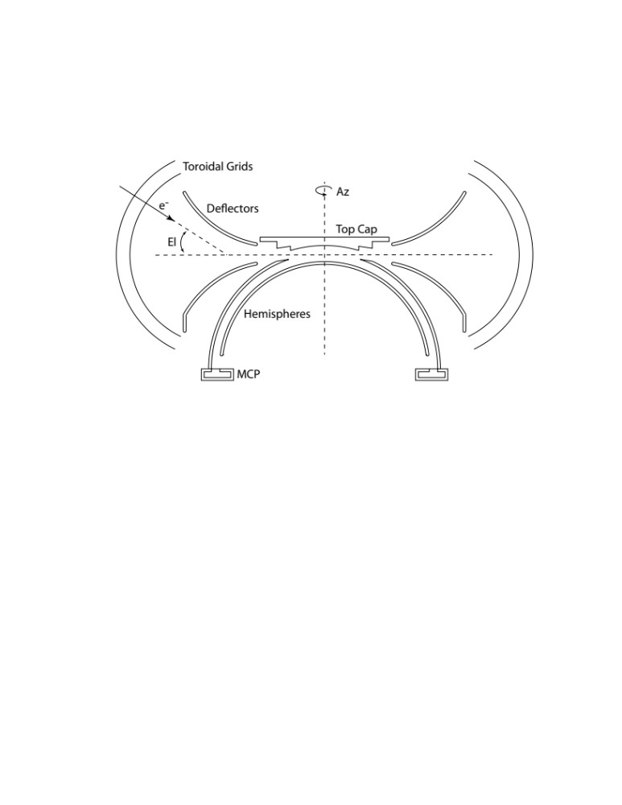
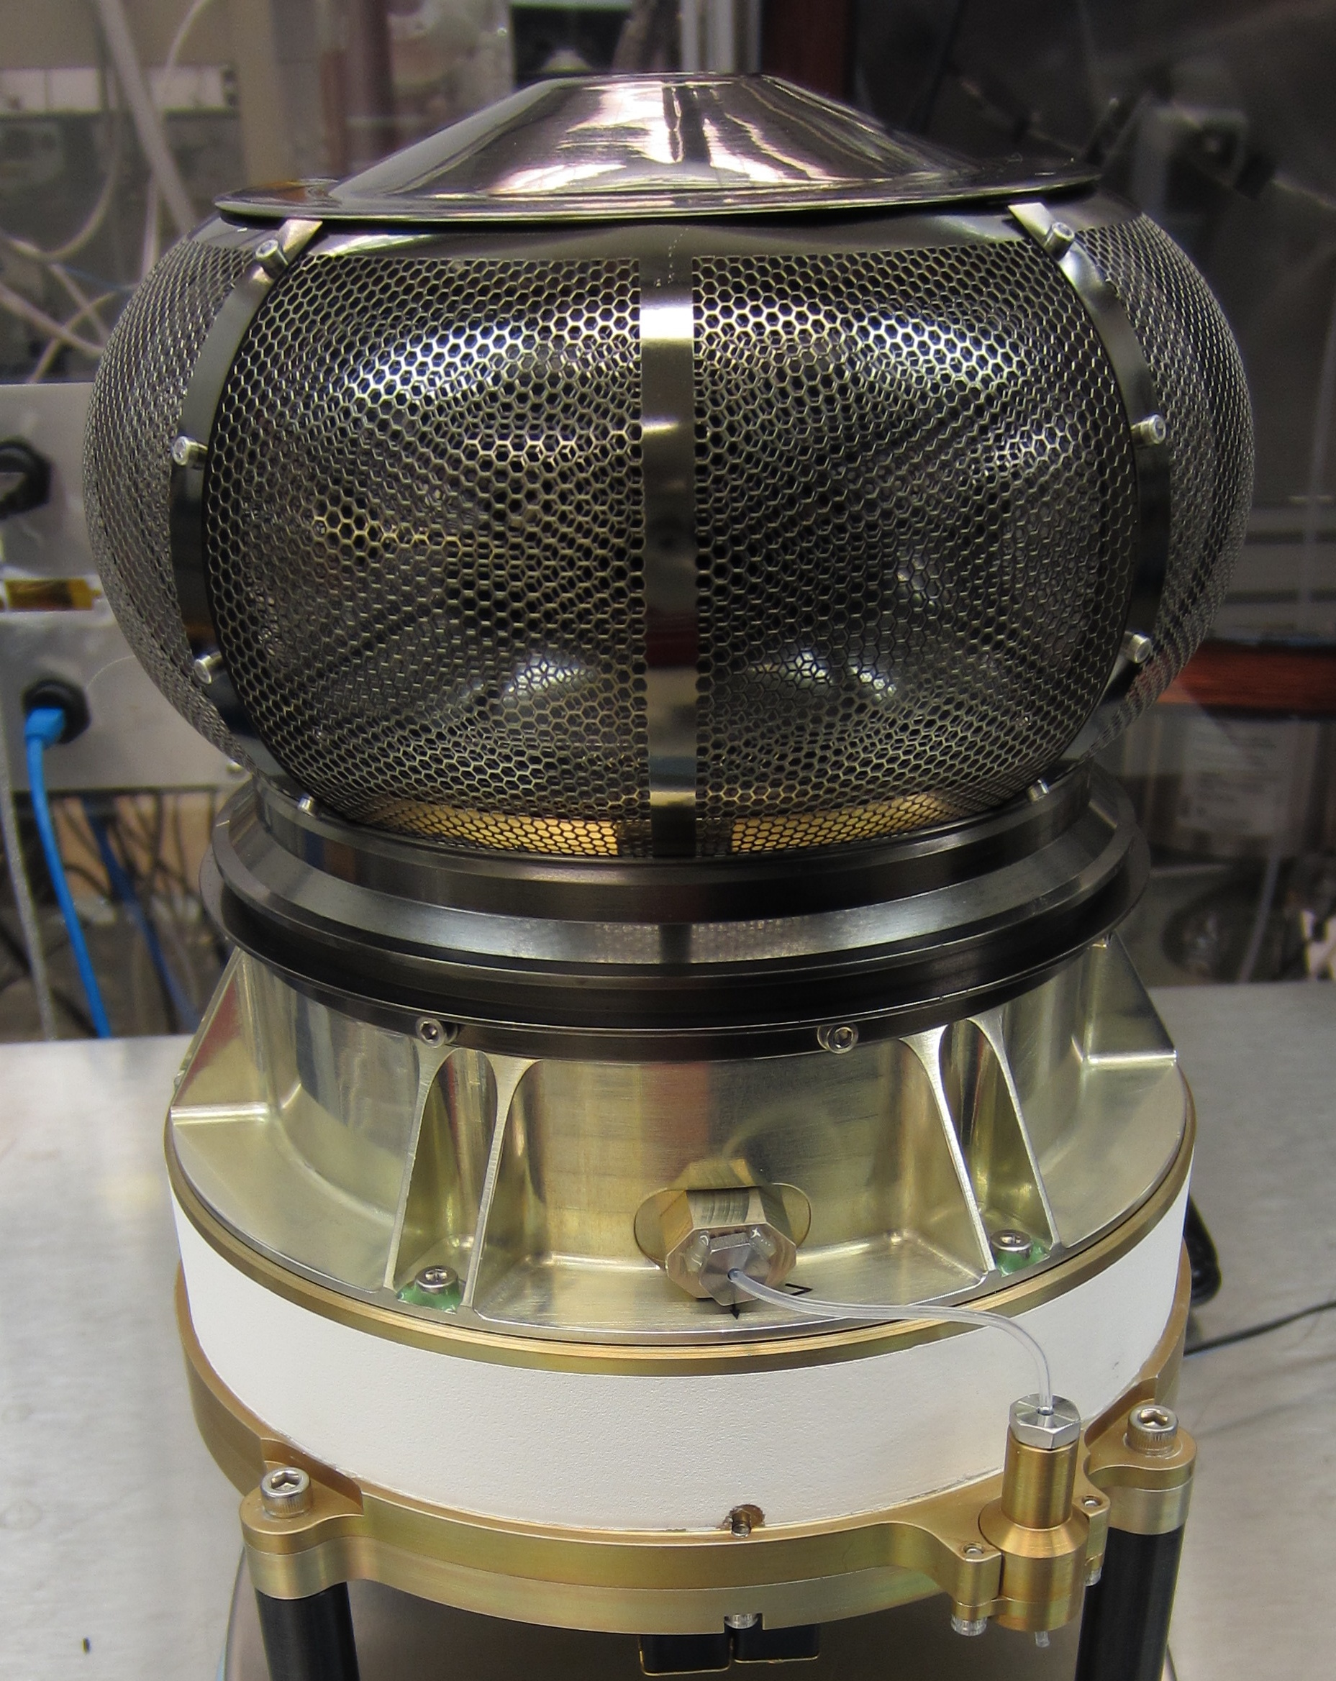
Figure 1: The MAVEN SWEA instrument (left) and analyzer cross-section schematic (above). Azimuth is measured about the instrument’s symmetry axis (vertical dashed line). Elevation is measured with respect to the instrument’s aperture plane (horizontal dashed line).

SWEA selects electrons within a given energy range by placing a potential difference between two concentric hemispheres. Electrons that pass through this analyzer are incident on a chevron pair of microchannel plates (MCPs) that amplify the signal by a factor of ~10⁶. The resulting electron cloud lands on a charge collecting anode that is segmented into 16 equal sized sectors, providing 22.5° azimuth resolution. The charge pulse on each anode sector is detected by one of 16 preamplifiers, which provide signals that are counted by a bank of counters in the digital electronics. The maximum count rate for each sector is limited by the deadtime (τ), which is effectively the time it takes the electronics to process a single event. During this time the detector is insensitive to any additional events, so the integration time is reduced by the factor (1 – R’τ), where R’ is the measured count rate.

The true count rate (R) is then:

$$R=R'{\left(1-R'τ\right)}^{-1}$$

The deadtime of the MCP-anode-preamp chain was measured to be 2.8 × 10⁻⁶ sec. The maximum true count rate per sector that can be reliably corrected for deadtime using the equation above is ~10⁶ s⁻¹. Data are flagged as bad whenever R' > 0.8/τ. The most likely location for this to occur is in the magnetosheath, just downstream of the bow shock, where shock-energized electron fluxes can sometimes saturate the detector from ~50 to ~200 eV. Depending on the solar wind conditions, this can happen for several consecutive orbits.
The field of view of the concentric hemispheres alone (with no voltage applied to the deflectors) is 360° x 7° (azimuth × elevation). An energy spectrum is obtained by sweeping the inner hemisphere potential from 0.5 to 750 V. With a measured analyzer constant of K_{a} = 6.17, this corresponds to an energy range of 3 to 4600 eV. The energy resolution is set by the gap between the hemispheres, and was measured to be ΔE/E (FWHM) = 17%.
Electrons entering the aperture pass through two concentric toroidal grids. The outer grid is tied to chassis ground (which is in turn tied to spacecraft ground), while the voltage of the inner grid can be commanded between 0 and −25 V. The electrical design is such that all surfaces interior to the inner toroidal grid (hemispheres, deflectors, top cap, exit grid) are referenced to the potential of the inner grid. In this way, the toroidal grids act as an electrostatic attenuator, decelerating incoming electrons without altering their trajectories or the electrostatic optics interior to the grids. This bias voltage, V₀, is controlled by the instrument’s sweep table.
It is useful to consider an incoming electron's energy at three locations: far from the spacecraft (E), just outside the outer toroidal grid, after it has been accelerated by the potential difference between the spacecraft and the ambient plasma (E'), and just after it has passed through both toroidal grids (E''). One mode of operation scales V₀ to the analyzer voltage:
$$V_{0}=\frac{E^{''}}{2}=\frac{V_{A}K_{a}}{2}$$
where V_{A} is the potential difference between the inner and outer hemispheres, and K_{a} is the analyzer constant (see Section 2.6). In this way, the energy resolution (ΔE/E, far from the spacecraft) is reduced by the factor f = 1/(1 + V₀/V_{A}K_{a}) = 2/3, and the geometric factor is reduced by f². This mode is effective up to energies of E'' = 50 eV (since the maximum value of V₀ is −25 V), or E' = 75 eV just outside the outer grid. The mode can be disabled simply by setting V₀ to zero throughout the sweep.
Electron angular distributions typically span the full sky, so it is important that the field of view (FOV) be as large as possible. On a spinning spacecraft, the instrument symmetry axis can be oriented orthogonal to the spin axis, which would sweep the hemispheres’ 360° x 7° FOV over the full sky every half-spin. However, MAVEN is a three-axis stabilized spacecraft, so SWEA uses deflectors to sweep the field of view in elevation by ±60°, resulting in an overall FOV of 360° × 120°, which represents 87% of the sky. The instrument is located at the end of a 1.5-meter boom (Fig. 2), at which distance the spacecraft blocks 8% of SWEA’s FOV. The unobstructed FOV is thus 79% of the sky.

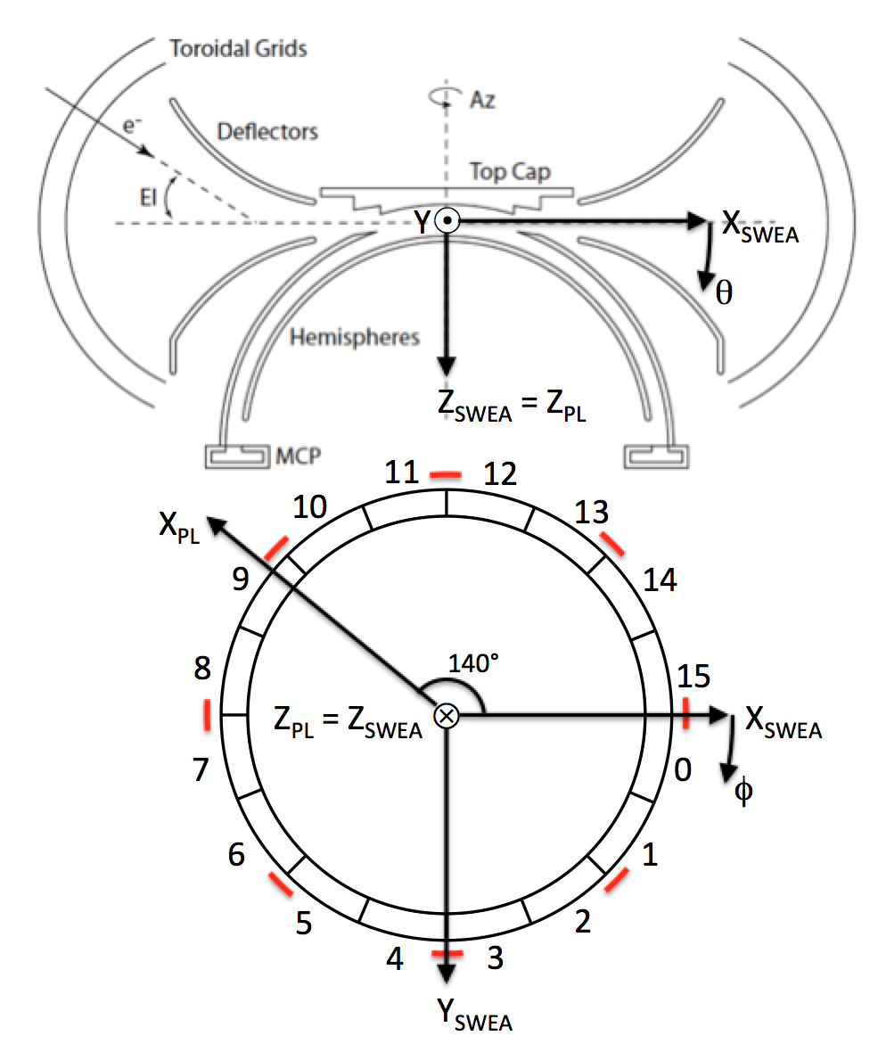
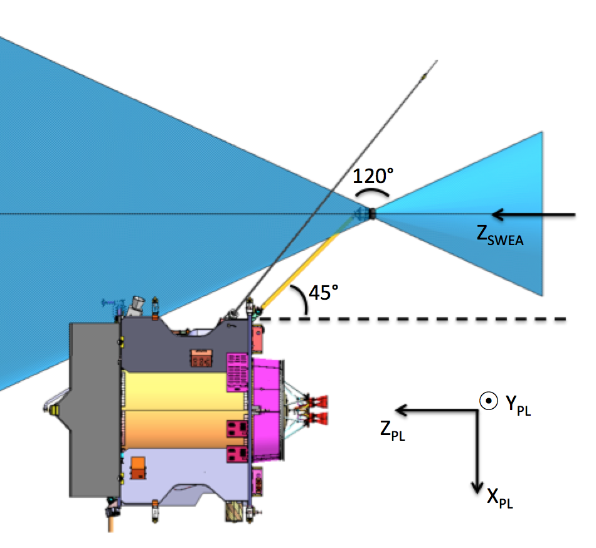
Figure 2b: SWEA coordinates are defined with respect to aperture plane and the anode layout, with the X axis at the boundary between anodes 15 and 0. To transform between spacecraft and SWEA coordinates, rotate about the Z axis by 140 degrees. Azimuth (ϕ) and elevation (θ) are defined with respect to SWEA coordinates. Red segments indicate the locations of support ribs for the toroidal grids (see also Fig. 12).
Figure 2a: SWEA is on the end of a 1.5-meter boom, with its symmetry axis (Z_{SWEA}) aligned with the spacecraft Z axis (Z_{PL}). SWEA has a 360° × 120° field of view (blue shading indicates the instrument's blind spots). When the spacecraft Z_{PL} axis points to the Sun, the SWEA electronics box shields the analyzer (including the toroidal entrance grids) from sunlight. This eliminates photoelectron production from the toroidal grids and within the aperture.

The deflection angle is a linear function of the ratio of the deflector voltage (V_{D}) to the analyzer voltage (V_{A}):
$$θ \left[deg\right]=10.89\left(\frac{V_{D}}{V_{A}}\right)-0.90$$
Thus, the deflection voltage needed to achieve a given deflection angle is proportional to the analyzer voltage (See section 2.6.2). The use of deflectors results in a non-uniform angular resolution in elevation. This is a property of the electrostatic optics, and results from the fact that the electrons can be deflected in the same or opposite sense as the trajectory within the hemispheres. The elevation resolution is 7° (FWHM) when the deflectors are both at ground (0° elevation), reaches a minimum of 3.3° at +30° elevation, and varies from about 15° at −60° elevation to 10° at +60° elevation. A more uniform elevation resolution is obtained by averaging over discrete deflector settings, so that the effective resolution is similar to the 22.5° azimuth resolution.
The geometric factor is a combination of electrostatic optics, grid transmissions, and MCP efficiency. The geometric factor was measured at IRAP using a calibrated electron beam and found to be G = 0.009 cm² ster eV/eV for all 16 anodes. The maximum energy flux that can be reliably measured is the maximum count rate per sector divided by the geometric factor per sector:

$$F_{max}=\frac{\left.{10}^{6}{ s}^{-1}\right.}{5.6 × {10}^{-4} {cm}^{2} ster}=1.8 × {10}^{9} {eV cm}^{-2} s^{-1} {ster}^{-1} {eV}^{-1}$$

Science Objectives
SWEA measures the energy and angular distributions of 3- to 4600-eV solar wind and magnetosheath electrons and ionospheric photoelectrons. With these measurements, the instrument: (1) determines the electron impact ionization rates in all regions sampled by MAVEN, (2) distinguishes the energy spectra of ionospheric primary photoelectrons and of solar wind, magnetosheath, and magnetotail electrons to determine plasma environment, (3) calculates electron pitch angle distributions to determine the topology of magnetic fields from both external and crustal sources, and (4) identifies auroral (~keV) electron populations and determines their role in ionization and dissociation processes.

Instrument Operation
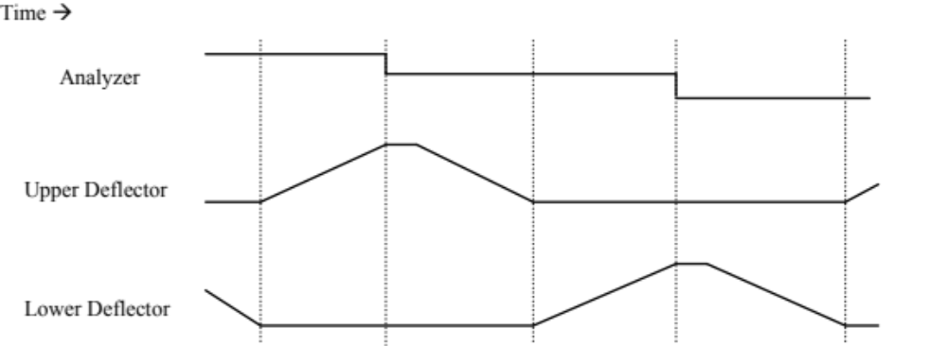
SWEA has a 2-second measurement cycle. The instrument takes data over the first 1.95 sec, as the potential difference between the hemispheres sweeps from its highest value of 750 V down to 0.5 V. This is followed by a 0.05-sec “gap”, during which time the instrument does not take data as the analyzer potential ramps back up and settles at 750 V in preparation for the next measurement cycle. The 1.95-sec data collection interval is divided into 1792 equal steps. During each of these steps, the analyzer and deflector voltages (V_{A},V_{D1}, and V_{D2}) and V₀ are commanded to discrete values according to the sweep pattern shown in Fig. 3. The analyzer voltage is commanded to 64 logarithmically spaced values from 750 V to 0.5 V, for a duration of 28 steps each. During each analyzer voltage setting, the deflectors are swept in linear ramps that are proportional to the analyzer voltage. This provides a constant angular coverage and resolution as a function of energy until the deflectors reach their maximum potential. To achieve a maximum deflection of 60°, the ratio V_{D}/V_{A} must be 5.5. Thus, for a maximum deflector potential of 1800 V (limited by the high voltage power supply), full deflection is achieved up to an analyzer voltage of 327 V, corresponding to an electron energy of 2 keV. At higher energies, the maximum deflection angle is inversely proportional to energy, falling to 26° at 4.6 keV.

Figure 3: Sweep pattern for the analyzer and deflector voltages. When enabled, V0 (not shown) is scaled to the analyzer voltage up to a maximum value of −25 V. Vertical dotted lines are at ~15 millisec intervals. Voltages are not to scale.

During the first 4 steps of each analyzer setting, the deflector voltages remain constant to allow time for all voltages to settle. (Data collected during these first 4 steps are later discarded by the PFDPU.) During the next 24 steps, the upper and lower deflectors are alternately ramped, while data are accumulated for each of the 16 anodes in 4-step intervals. This provides six elevation bins with ~20-degree elevation resolution (up to 2 keV), which is similar to the 22.5-degree azimuth resolution and partially compensates for the instrument’s intrinsic variable elevation resolution. Above 2 keV, the deflection bin sizes scale with the maximum deflection angle, providing uniform deflection angle coverage as the FOV shrinks. There are a total of 16×6 = 96 azimuth-elevation bins for each of 64 energy bins.

Measured Parameters
During each 2-second measurement cycle, SWEA generates 448 messages (4-step accumulations of the 1792 data collection steps), with each message consisting of sixteen 16-bit counter values, one for each anode. The accumulation time per anode is 1.95/448 = 4.35 msec. The PFDPU discards the first of every seven messages that comprise the deflector sweep (to allow for setting time) and organizes the remaining 384 messages into a 64-energy × 16-azimuth × 6-elevation distribution. In order to make best use of SWEA’s total telemetry allocation, the PFDPU calculates three data products from this distribution: 3D spectra, pitch angle distributions (PADs), and energy spectra (SPECs). The cadence of each data product is a multiple of 2 sec, which can be set independently of the other data products. All three data products are synchronized, so that each 3D product corresponds precisely to PAD and SPEC data products obtained over the same measurement cycle. This makes it possible to intercompare the data products, which are summed on-board in different ways and sampled with different cadences.
As it receives SWEA data messages, the PFDPU sorts the data in energy and angle, accumulating counts in 19-bit registers. At the end each accumulation interval, the 19-bit values are compressed to 8 bits using a scheme that provides 1-count resolution up to 32 counts, 2-count resolution for the next 16 values, 4-count resolution for the next 16, and so on (Table 5).

Table 5: 19-to-8 Compression
0 1 2 3 4 5 6 7 8 9 10 11 12 13 14 15
16 17 18 19 20 21 22 23 24 25 26 27 28 29 30 31
32 34 36 38 40 42 44 46 48 50 52 54 56 58 60 62
64 68 72 76 80 84 88 92 96 100 104 108 112 116 120 124
128 136 144 152 160 168 176 184 192 200 208 216 224 232 240 248
256 272 288 304 320 336 352 368 384 400 416 432 448 464 480 496
512 544 576 608 640 672 704 736 768 800 832 864 896 928 960 992
1024 1088 1152 1216 1280 1344 1408 1472 1536 1600 1664 1728 1792 1856 1920 1984
2048 2176 2304 2432 2560 2688 2816 2944 3072 3200 3328 3456 3584 3712 3840 3968
4096 4352 4608 4864 5120 5376 5632 5888 6144 6400 6656 6912 7168 7424 7680 7936
8192 8704 9216 9728 10240 10752 11264 11776 12288 12800 13312 13824 14336 14848 15360 15872
16384 17408 18432 19456 20480 21504 22528 23552 24576 25600 26624 27648 28672 29696 30720 31744
32768 34816 36864 38912 40960 43008 45056 47104 49152 51200 53248 55296 57344 59392 61440 63488
65536 69632 73728 77824 81920 86016 90112 94208 98304 102400 106496 110592 114688 118784 122880 126976
131072 139264 147456 155648 163840 172032 180224 188416 196608 204800 212992 221184 229376 237568 245760 253952
262144 278528 294912 311296 327680 344064 360448 376832 393216 409600 425984 442368 458752 475136 491520 507904

Raw 19-bit values are rounded down, so each 8-bit value corresponds to a range of possible counts. For example, a telemetry value of 96 decompresses to 512, which corresponds to a range of 512-543 counts. The middle of each range is provided in the SWEA data products, so it is possible to have half counts. The maximum number of counts in this scheme is 524287 (2¹⁹ – 1), which is rounded down to 507904. This 2.5 times larger than needed, even when the instrument is counting at its maximum rate. Since each telemetry value corresponds to a range of possible counts, this scheme introduces digitization noise, which dominates the statistical variance at high count rates.
If we approximate digitization noise as additive white noise, then the variance, S, is given by:
$$S=N+\frac{\left(M^{2}-1\right)}{12}$$
where N is the decompressed counter value, and M is the total number of 19-bit values that map into N. Using the example above: N = 527.5, M = 32, and S = 612.75. Note that at 1-count resolution (M = 1), there is no contribution from digitization noise.

3D Distributions
At the highest resolution, a 3D spectrum consists of 64 energies × 16 azimuths (anode bins) × 6 elevations (deflection bins). Adjacent azimuth sectors are averaged at the highest positive and negative elevations to provide a more uniform solid angle resolution. For ease of use, we maintain 16 azimuth bins for all elevations. For the highest positive and negative deflections, we duplicate the binned counts for each pair of binned azimuths and maintain an angular binning factor for subsequently calculating count rate or converting to physical units. (Duplicating the counts in two adjacent bins effectively doubles the integration time for each of those bins.) The angular binning factor is 2 for the highest positive and negative deflections, and 1 for all other deflections. The distribution can be further averaged in groups of 2 or 4 adjacent energy steps. We duplicate binned counts in groups of 2 or 4, as appropriate, to maintain 64 energy bins. This introduces an energy binning factor, which is used in the same way as the angular binning factor. Finally, the distribution can be sampled every 2^{N} two-second measurement cycles, where N is an integer (N ≥ 0). Raw decompressed counts and binning factors are provided in the 3D data products to allow calculation of statistical uncertainties; however, care must be taken, since duplicated bins are not independent.

Pitch Angle Distributions
The most scientifically relevant way to organize the electron angular distribution is with respect to the magnetic field. The angle between an electron’s velocity vector and the magnetic field vector is defined as the “pitch angle”, which ranges from 0° (parallel) to 180° (anti-parallel). These pitch angle distributions (PADs) are generated onboard by flight software in the PFDPU. The first step is to perform a basic calibration of the magnetic field vector and then rotate the vector into SWEA instrument coordinates, so that the 96 azimuth-elevation pairs can be mapped into pitch angle. The pitch angle distribution that is placed in telemetry is composed of 16 values: one for each of the 16 azimuth sectors. Flight software determines the optimal deflection bin for each azimuth sector that maximizes the total pitch angle coverage. The solution is a great circle entirely within the FOV that contains the magnetic field vector, or comes as close a possible to doing so. This guarantees that a complete pitch angle distribution is obtained whenever the magnetic field vector is within SWEA’s FOV, and that any gaps are not larger that the instrument’s intrinsic blind spots (|θ| > 60°, see Figure 2).
Since the 16 PAD bins span 360° in azimuth, there is two-fold redundancy. That is, the pitch angle distribution is measured twice, once for each half of the detector. This redundancy can be used to monitor the calibration in fight, which is expected to change gradually as the MCPs age. The basic calibration performed onboard is sufficient to optimize the pitch angle coverage provided by this data product. No information is lost in producing a PAD onboard, since it is obtained without averaging in angle. To produce calibrated L2 PAD data, the pitch angle mapping is refined on the ground by using fully calibrated Magnetometer data. The average pitch angle and the range of pitch angles spanned by each bin is provided in the PAD data product.
PADs can be averaged in groups of 2 or 4 adjacent energy steps. As before, we duplicate binned counts, as appropriate, to maintain 64 energy bins. The distribution can also be sampled every 2^{N} two-second measurement cycles. The PAD energy binning and time sampling can be different from those used in the 3D data product. Raw decompressed counts and binning factors are provided in the PAD data products to allow calculation of statistical uncertainties.

Energy Spectra
Energy spectra are obtained by taking a weighted average of all 96 azimuth-elevation bins. Before summing, the counts are multiplied by cos(θ) to account for variation of the solid angle spanned by each bin:
$$ΔΩ=2 Δϕ \sin\left(\frac{Δθ}{2}\right) \cos{θ}$$
where Δϕ and Δθ are the angular widths in azimuth (22.5°) and elevation (20°), and θ is the center elevation. To within a constant scaling factor, this weighted summation over angular bins approximates the angular summation of a density moment calculation. The energy summation can be performed on the ground, or the energy spectrum can be fit with a model to estimate density and temperature.
A weighting factor is provided in the SPEC data product to allow conversion of weighted counts to mean raw count rate per anode, which allows an estimate of dead time for the summed data. The 3D data can be used to evaluate the accuracy of this estimate, albeit at a lower cadence. Energy spectra always contain all 64 energy steps to provide the best possible energy resolution, and they can be either sampled or summed over every 2^{N} two-second measurement cycles.

Operational Modes
The instrument has one operational mode, which produces 448 messages synchronized to the sweep pattern every 2-second measurement cycle. Energy averaging and time sampling are performed in the PFDPU when calculating the three SWEA data products. Energy sampling for 3D and PAD products and time sampling for all three products are parameterized and can be adjusted by command to manage SWEA’s data production rate. Thus, as the overall telemetry bandwidth varies during the mission (because of the changing Earth-Mars distance), SWEA’s data production can vary accordingly.
The energy and time sampling parameters are used to define two data collection modes: solar wind mode and ionosphere mode. Solar wind mode is used at high altitudes, where high resolution is less important. This allows us to expend a greater fraction of SWEA’s total telemetry allocation to achieve higher resolution at low altitudes. The transition altitude between these two modes is adjustable on the ground; it will be 2000 km at the start of science operations in November 2014.
Each data collection mode produces two data streams: survey and archive. The survey stream provides sufficient resolution to achieve SWEA’s scientific goals, and is placed into telemetry in its entirety. The archive stream contains higher energy and/or time resolution and is stored in flash memory within the PFDPU. Only a fraction of the archive data can be telemetered to the ground. Telemetry bandwidth for sending archive data is obtained by lossless compression of the survey data stream. Typically a factor of ~2 compression is achieved, which provides space for ~10% of the archive data. At each contact (nominally twice per week), survey data are reviewed and time ranges of interest are selected. Commands are then sent to the PFDPU at the next contact to downlink the archive data covering the desired time range(s). The archive data have the same format as the survey data. The only differences are the energy and/or time resolutions.
Each of the data products is a time series of an array with dimensions of energy and angle. Changes in time sampling are naturally accounted for in the time series. The number of angles is fixed for each product: 3D (96), PAD (16), and energy spectra (no angle dimension). As noted above, Energy spectra always have 64 energy channels. However, changes in energy averaging can alter the dimensions of the energy/angle arrays. To maintain fixed array dimensions for each of the data products (3D, PAD, energy spectra), all arrays are sized to accommodate the maximum number of energy channels (64). When energy averaging reduces the number of energy bins to 32 or 16, the raw counts are duplicated in groups of 2 or 4 adjacent energy bins to maintain a total of 64 bins, and a binning factor (B = 2 or 4) is recorded to allow calculation of raw count rate.

Operational Considerations

Spacecraft Charging and Photoelectrons
A spacecraft orbiting Mars can experience widely different environments in terms of plasma density, electron temperature, and ionizing radiation. Solar ultraviolet light causes photoelectron emission, which represents a positive current into the spacecraft. Impacts of ambient charged particles also represent a current to the spacecraft, with the net plasma current negative because electrons have higher thermal velocities (and therefore fluxes) than do ions. Other currents are produced by secondary emission of electrons generated by electron and ion impact, but these currents are highly material-dependent. The spacecraft responds almost instantly to these different environments by reaching an electrostatic potential such that the net current to the spacecraft is zero. This potential affects plasma measurements by shifting the energies of incoming ions and electrons, bending the trajectories of low energy and low mass charged particles, and repelling like-charged particles with energies at or below the potential.
In low density environments (basically anywhere outside the ionosphere) when the spacecraft is in sunlight, the dominant current results from photoelectrons emitted by the spacecraft. This causes the spacecraft to charge positive until it reaches a potential sufficient to attract enough photoelectrons back to the spacecraft to achieve zero net current. The magnitude of this potential depends on the flux of ionizing radiation and the local plasma density, as well as the photoemission and secondary emission properties of the spacecraft (Figure 4). Typical values upstream of Mars’ bow shock and in the magnetosheath, where the ambient density exceeds a few × 10⁻¹ cm⁻³, range from a few volts up to +10 V.

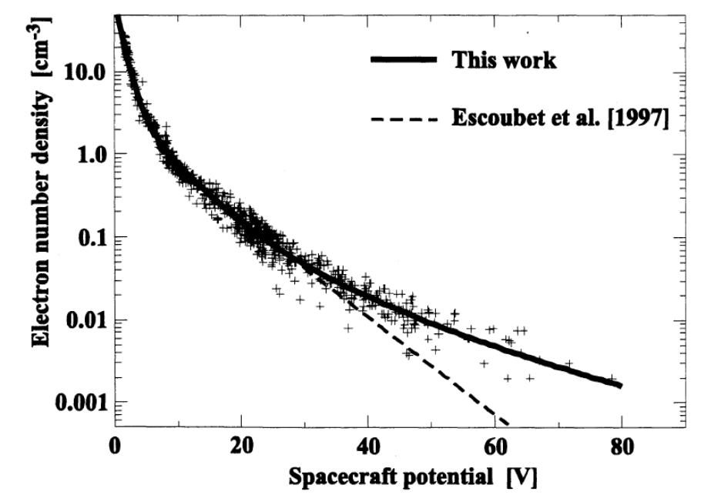
Figure 4: Charging of the Geotail spacecraft in sunlight. (Ishisaka et al., 2001). The curve for MAVEN has not yet been measured but is expected to be similar.

By tracking the positions of low-energy features in the electron energy spectrum, the ASPERA-3-ELS experiment onboard Mars Express measured spacecraft potentials in the magnetosheath of typically less than +8 V, although potentials up to +10 V were occasionally observed (Frahm et al. 2006).
In the ionosphere, where the plasma density is orders of magnitude higher (Figure 5), the current resulting from ambient charged particles impacting the spacecraft can dominate the photoelectron current, and the spacecraft will charge to a negative potential comparable in magnitude to the local electron temperature. Below ~200 km altitude, the ionospheric electron temperature is a few hundredths of an eV, increasing to a few tenths of an eV from ~200 to ~400 km. When in the ionosphere, the ELS instrument on Mars Express measured potentials of a few volts negative (Frahm et al. 2006).
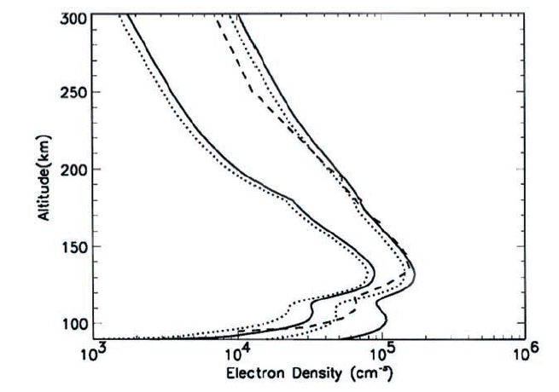
solar min
solar max
Figure 5: Electron density profiles in Mars’ ionosphere away from crustal magnetospheres for solar minimum and maximum conditions (after Fox 2004).

The largest potentials should occur when the spacecraft is in the magnetotail and in the planet’s shadow, where photoemission is absent. The relatively high electron temperatures in this region typically result in spacecraft potentials of several tens of volts negative, as estimated from MGS Electron Reflectometer data by comparing electron energy spectra obtained in the optical shadow with those obtained in sunlight. Much larger negative potentials (hundreds to thousands of volts) have been observed in shadow in the Earth’s magnetosphere (cf. Whipple, 1981 and references therein) when energetic electron populations are present. Such large potentials could also occur at Mars.
At high altitudes in sunlight, MAVEN charges to a positive potential (φ) of several volts. Spacecraft photoelectrons with energies below φ are attracted back to the spacecraft, while those with energies above φ escape. Meanwhile, ambient electrons are attracted to the spacecraft and shifted in energy. Thus, an instrument mounted on (and at the same potential as) the spacecraft measures spacecraft photoelectrons below φ and ambient electrons above φ. SWEA’s energy range extends down to 3 eV, so that both populations are typically observed. The boundary between the two populations is marked by a sharp change or reversal of slope in the energy spectrum at E = φ. Energy spectra, with 64 energy channels, can be used to provide the most accurate measure of φ, which can then be used to correct the energy scales of all three data products. An independent measure of the spacecraft potential is provided by the Langmuir Probe and Waves (LPW) experiment. LPW can provide estimates of spacecraft potential outside of SWEA's range (φ > +3 V).

Field of View and Spacecraft Blockage
If there were no spacecraft, SWEA’s 360° × 120° field of view (FOV) would cover 87% of the sky. However, even on the end of a boom, 8% of the sky within SWEA’s FOV is blocked by the spacecraft. SWEA is at a fixed location at the end of a 1.5-meter boom (Fig. 2), so the spacecraft maps into a fixed range of azimuth and elevation. The affected angular bins are flagged in the 3D and PAD data products.

Energy-Dependent Field of View
As described in Section 2.2, SWEA’s field of view is energy dependent above 2 keV, because the deflector high voltage supply tops out at 1800 V. Above 2 keV, the deflection range decreases with energy, ranging from ±60° (full deflection) at 2 keV to ±26° at 4.6 keV. The elevation bins are scaled accordingly to provide uniform angular sampling within the available range. Since the FOV depends on the sweep pattern (Fig. 3), it is possible for the FOV to change during the mission if the sweep pattern changes. Consequently, an energy-azimuth-elevation array is provided to describe SWEA’s energy-dependent field of view.
Note that pitch angle distributions are more likely to have reduced coverage as the instrument’s FOV shrinks at energies above 2 keV. The algorithm for optimizing the pitch angle coverage of the PAD data product was designed for the full ±60° deflection range, and will be less effective for reduced deflection ranges.

Ground Calibration

Energy-Angle Response
The instrument energy-angle response was measured in a calibration vacuum chamber for manipulator yaw values ranging from −50° to +60°. (Contact between the harness and the chamber wall prevented more negative yaws.) With the electron beam energy held constant at 1 keV, the analyzer and deflector voltages were varied to map the response function.
In the following figures, the measured response is compared with simulations for three sample yaws: 0° and ±45°. Energy is represented as K, which is the ratio of the electron beam energy to the potential difference between the hemispheres (V_{A}). Deflection angle is a linear function of the ratio of the deflector potential to the analyzer potential (V_{D}/V_{A}). This function is calibrated and used to convert V_{D}/V_{A} to angle in the measured distributions. In the simulations, angle is determined directly from the particle trajectories.

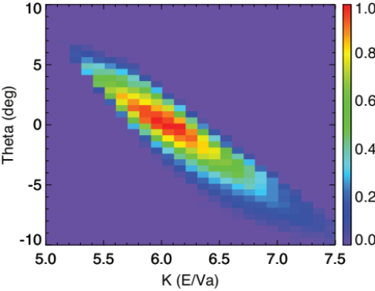
Simulation

Simulation
Figure 6: Measured energy-angle response, normalized to unity, at a mechanical yaw of 0 deg (top left). Theta is the deflection angle achieved by varying the deflector voltages (see Fig. 9), and K is ratio of the beam energy (Ebeam) to the analyzer voltage (Va). In this calibration run, the beam energy was held constant while the analyzer voltage was varied. The line drawings are the integrated responses, renormalized to unity, in angle (upper right) and energy (lower left). The simulation (lower right) has been shifted by ΔK = −0.44 (see text).

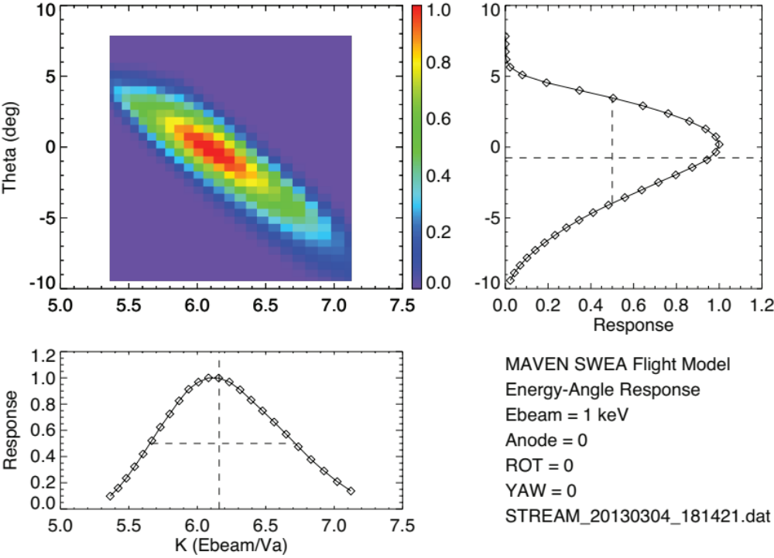
The simulated response must be shifted by ΔK = −0.44 to provide the best agreement with the measured response. This corresponds to a slight increase (~0.2 mm) in the actual gap between the hemispheres compared with the simulated geometry. This difference can be attributed to two sources. First, the simulated geometry does not include scalloping of the inner and outer hemispheres and the top cap. These rounded grooves are 0.24 mm in depth relative to the simulated radii of curvature, so the effective gap is expected to be larger than the simulated gap. Second, the observed variation in K as a function of azimuth (see below), which is a measure of hemisphere concentricity, indicates that mechanical tolerances are of order 0.1 mm. After shifting the simulated energy-angle response, the agreement between measurement and simulation is excellent.
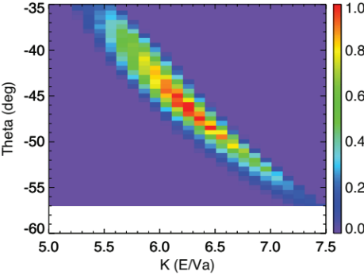
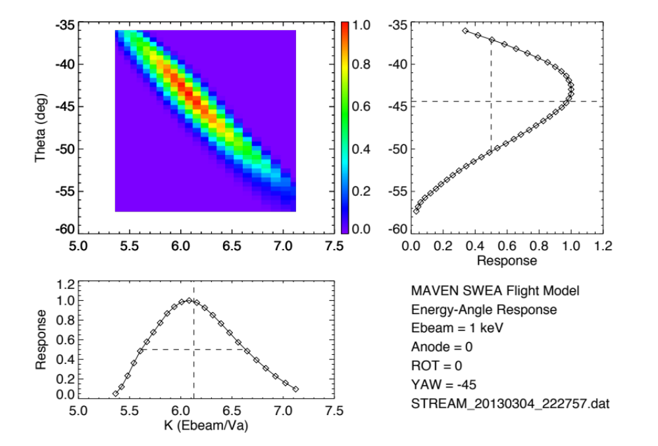
Simulation

Figure 7: Measured energy-angle response (top left and both line drawings) and simulated response (lower right) for a yaw of −45°. In the simulation, K is shifted by the same amount as for zero yaw. See caption to Fig. 6.

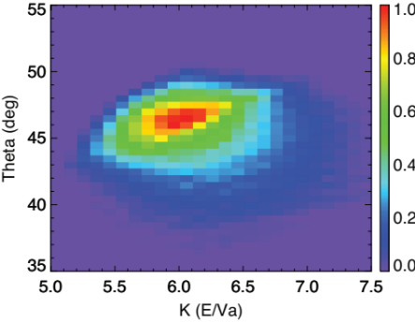
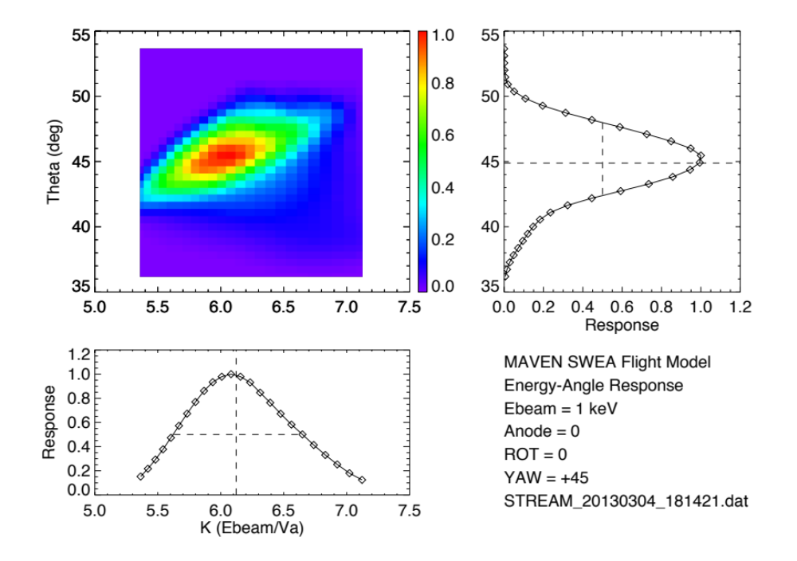
Simulation
Figure 8: Measured energy-angle response (top left and both line drawings) and simulated response (lower right) for a yaw of +45°. In the simulation, K is shifted by the same amount as for zero yaw. See caption to Fig. 6.

Deflector Calibration
Measured response functions at manipulator yaws ranging from −50° to +60° were used to determine the relationship between deflection angle and the ratio of the deflector potential (V_{D}) to the analyzer potential (V_{A}). Simulations predict that this relationship should be very nearly linear over the full deflection range, until the deflectors themselves begin to impinge on the FOV at the largest deflection angles.

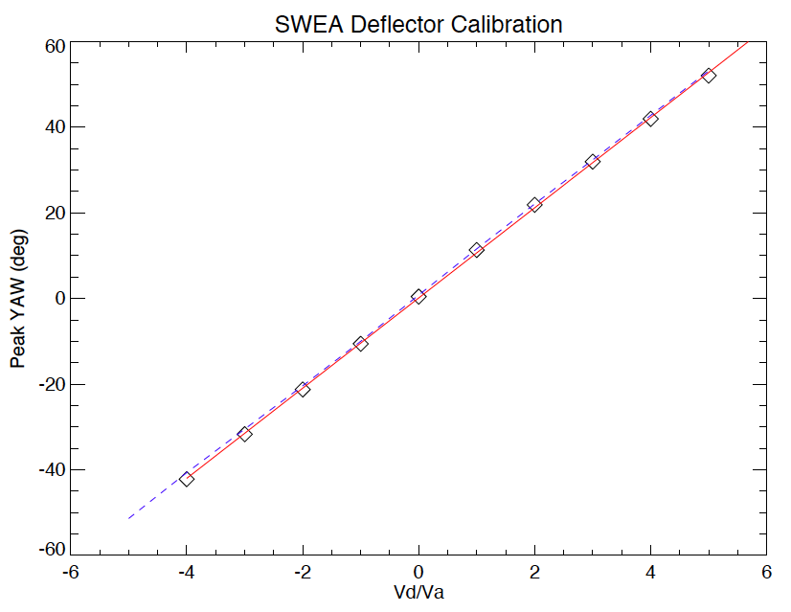
Figure 9: Mechanical yaw as a function of V_{D}/V_{A}. Diamond symbols are the measured values, and the red line is a linear fit to those measurements. The blue dashed line is derived from detector simulations.

The measurements (upward and downward deflections combined) are well fit with a linear function:

$$θ \left[deg\right]=10.89\left(\frac{V_{D}}{V_{A}}\right)-0.90$$

This agrees with simulation to within ~1°, which is comparable to the accuracy with which the instrument is mounted to the manipulator, and is much smaller than the instrument’s elevation resolution (~20 deg).

Analyzer Constant and Energy Resolution
The analyzer constant (K_{a}) is the ratio of the energy of transmitted electrons to the potential difference between the hemispheres (or analyzer voltage, V_{A}). The beam energy is held constant while the analyzer energy-angle response is measured, as described above. Integrating this distribution over angle provides an energy response function (Fig. 10). The weighted mean value of K for this distribution (Σ (K×R) / Σ R), where R is the normalized response) is the analyzer constant, and the full width at half maximum (FWHM) is a measure of the energy resolution.

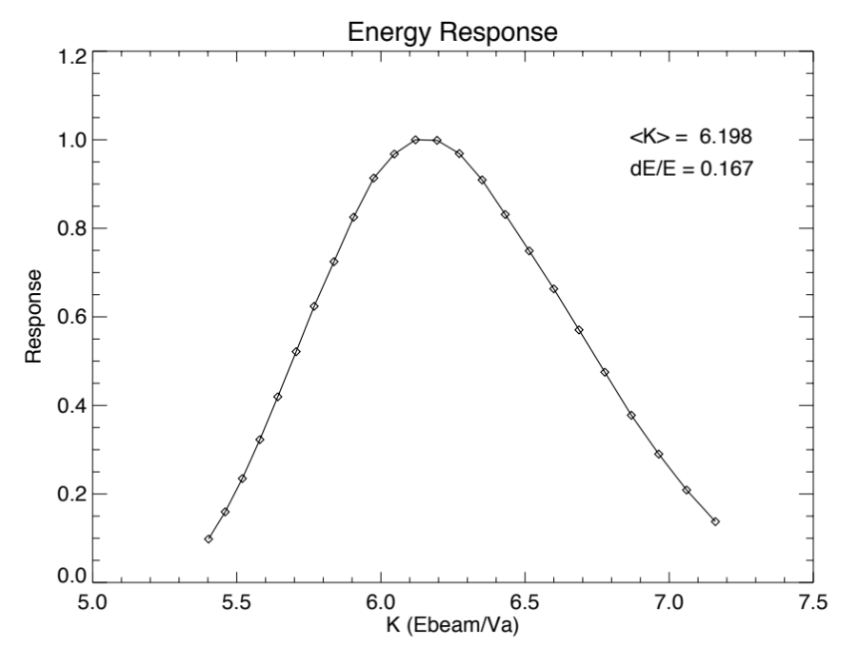
Figure 10: Energy response obtained by integrating the measured energy-angle response function at a yaw of zero (Figure 6). The weighted mean value of K and the energy width (ΔE/E, FWHM) are indicated.

The analyzer constant measurement was repeated as a function of azimuth (Fig. 11) by setting manipulator roll to 16 positions around the 360° FOV, all with yaw at 0.
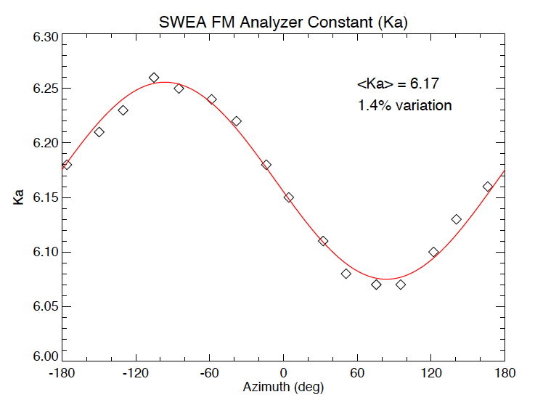

Figure 11: Analyzer constant (K_{a}) as a function of azimuth around the FOV. The red line is the best fit sine function.

The results are well fit with a sine function, which indicates that the most likely cause for the variation in a slight misalignment of the hemispheres. A misalignment of ~0.1 mm would explain the amplitude of the variation. This results in a 1.4% variation in the energy response around the field of view, which is small compared with the energy resolution (ΔE/E, FWHM) of 17%.
The analyzer constant and energy resolution do not vary significantly with elevation up to +55°. (The experimental setup at SSL did not permit yaws less then −50°.) Table 6 summarizes results as a function of yaw. The value for yaw = 0 corresponds to Figures 6 and 10.

Table 6: Analyzer constant and energy resolution as a function of mechanical yaw with respect to the beam direction.
YAW | <K> | ΔE/E (FWHM)
−45 | 6.166 | 0.160
−30 | 6.188 | 0.169
0 | 6.198 | 0.167
+30 | 6.164 | 0.167
+45 | 6.161 | 0.169
+55 | 6.156 | 0.168

Azimuthal Response and Field of View
The azimuthal response of the instrument was measured by setting the instrument voltages for the center of the response function for a 4 keV beam at yaw = 0 and then rotating the detector at a constant rate about the symmetry axis by 380° (to provide some overlap). As the instrument rotates and collects data, each anode in turn is illuminated by the electron beam.

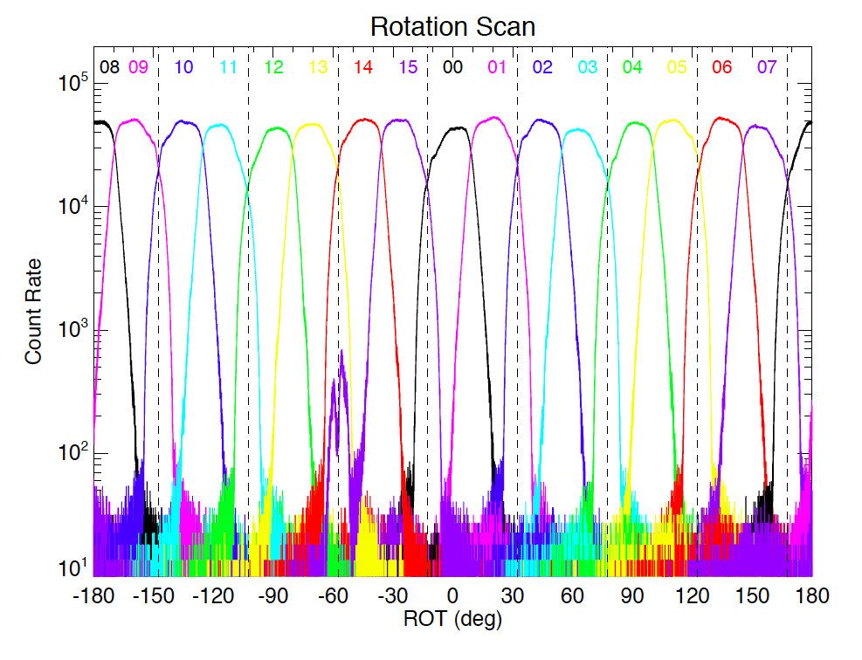
Figure 12: Detector response as a function of azimuth around the field of view at yaw=0. The responses of all 16 anodes (numbered 0 through 15) are shown. Vertical dashed lines indicate the locations of support ribs for the toroidal grids.

The 16 sectors provide 22.5° resolution over a 360° range of azimuth. There is no measureable cross talk between the sectors, except for sector 15, which exhibits peak cross talk at the ~1% level.

In-flight Calibration
Angular and energy resolution and accuracy is determined for SWEA, SWIA, and STATIC by calibration on the ground and verification of electrostatic optics simulations. Therefore, the only unknown is the absolute sensitivity of the instrument, which depends on the absolute efficiency of the microchannel plates (MCPs). Therefore, it suffices to use the total plasma density measured by each analyzer as a calibration point to determine the absolute MCP efficiency.
LPW measures the plasma frequency between 90 kHz and 1.67 MHz, which corresponds to a total plasma density between 100 cm⁻³ and 3×10⁴ cm⁻³. This density range will be seen throughout the upper ionosphere, allowing many measurements of plasma density that can be compared with STATIC. LPW measurements of plasma frequency are sufficient to determine the plasma density to within 5%.
In the ionosphere, STATIC will measure ram ions. Since the ram velocity of the spacecraft is much larger than the local thermal velocity and the ram energy of the ions is much larger than the expected spacecraft potential, STATIC will measure the entire ion distribution. Therefore, the only limiting factors on the accuracy of the ion density measurement from STATIC in the upper ionosphere are the spacecraft potential, and Poisson counting statistics.
For a typical periapsis velocity of ~4.5 km/s and an ion mass in the 16-32 range, the ram energy of the ions is on the order of 2 eV. Meanwhile, the plasma temperature and the spacecraft potential will be on the order of 0.1 eV in the ionosphere. For these values, even if we had no a priori knowledge of the spacecraft potential, STATIC could provide density measurements with a relative accuracy of ~0.1/2.0 = 5% (STATIC essentially measures the flux, n×v, so the error in v resulting from the spacecraft potential can be directly related to an error of the same magnitude in n).
In fact, we should also have some a priori knowledge of the spacecraft potential both from the shape of the measured distribution functions and from the I-V curve measured by LP, which will increase the fidelity of this measurement still further.
Finally, count rates are large enough that errors from Poisson statistics should be essentially negligible, certainly less than 5%.
Therefore, even in the worst case of error propagation, we expect to be able to calibrate STATIC plasma density measurements in the ionosphere to better than 15%. In fact, errors should add in quadrature, so we can calibrate STATIC to 10%.
As an alternative, STATIC can determine absolute START and STOP efficiencies from ratios START/(START+STOP) and STOP/(START+STOP) events, which can be combined with mechanical analyzer geometric factor knowledge from electrostatic optics simulations to get an absolute sensitivity, with error determined by mechanical tolerance and supported by analyzer energy constant. This procedure will work whenever one ion species dominates – for instance in the solar wind or outer magnetosheath. The results of this analysis should agree with cross calibration with LPW, providing a consistency check.
SWIA and STATIC can be calibrated directly to each other in the magnetosheath or in the solar wind at times with less intense fluxes. This calibration can be performed without any requirement for measuring or calculating a total density, since the two sensors have overlap in both energy and angular coverage. Since the two sensors have exactly the same analyzer electrostatic optics, there are very few uncertainties in this calibration. We estimate that this calibration can easily be made to an accuracy of 5%. Therefore, SWIA can be calibrated to better than 15% (assuming 10% accuracy of STATIC calibrations).
Finally, SWEA can be calibrated to both SWIA and STATIC in the sheath and/or solar wind. This is a well-understood procedure with extensive heritage from THEMIS and other spacecraft. We estimate that this calibration can easily be done to 10% accuracy, ensuring that SWEA can be calibrated to better than 25%.

Data Overview
This section provides a high level description of archive organization under the PDS4 Information Model (IM) as well as the flow of the data from the spacecraft through delivery to PDS. Unless specified elsewhere in this document, the MAVEN SWEA archive conforms with version 1.4.0.0 of the PDS4 IM [4] and version 1.0 of the MAVEN mission schema. A list of the XML Schema and Schematron documents associated with this archive are provided in Table 7 below.
Table 7: MAVEN SWEA Archive Schema and Schematron
XML Document | Steward | Product LID
PDS Master Schema, v. 1.4.0.0 | PDS | urn:nasa:pds:system_bundle:xml_schema:pds-xml_schema
PDS Master Schematron, v. 1.4.0.0 | PDS | urn:nasa:pds:system_bundle:xml_schema:pds-xml_schema
MAVEN Mission Schema, v. 1.0.2.1 | MAVEN | urn:nasa:pds:system_bundle:xml_schema:mvn-xml_schema
MAVEN Mission Schematron, v. 1.0.2.1 | MAVEN | urn:nasa:pds:system_bundle:xml_schema:mvn-xml_schema

Data Processing Levels
A number of different systems may be used to describe data processing level. This document refers to data by their PDS4 processing level. Table 8 provides a description of these levels along with the equivalent designations used in other systems.
Table 8: Data processing level designations
PDS4 processing level | PDS4 processing level description | MAVEN Processing Level | CODMAC Level | NASA Level
Raw | Original data from an instrument. If compression, reformatting, packetization, or other translation has been applied to facilitate data transmission or storage, those processes are reversed so that the archived data are in a PDS approved archive format. | 0 | 2 | 1A
Reduced | Data that have been processed beyond the raw stage but which are not yet entirely independent of the instrument. | 1 | 2 | 1A
Calibrated | Data converted to physical units entirely independent of the instrument. | 2 | 3 | 1B
Derived | Results that have been distilled from one or more calibrated data products (for example, maps, gravity or magnetic fields, or ring particle size distributions). Supplementary data, such as calibration tables or tables of viewing geometry, used to interpret observational data should also be classified as ‘derived’ data if not easily matched to one of the other three categories. | 3+ | 4+ | 2+

Products
A PDS product consists of one or more digital and/or non-digital objects, and an accompanying PDS label file. Labeled digital objects are data products (i.e. electronically stored files). Labeled non-digital objects are physical and conceptual entities which have been described by a PDS label. PDS labels provide identification and description information for labeled objects. The PDS label defines a Logical Identifier (LID) by which any PDS labeled product is referenced throughout the system. In PDS4 labels are XML formatted ASCII files. More information on the formatting of PDS labels is provided in Section 0. More information on the usage of LIDs and the formation of MAVEN LIDs is provided in Section 5.1.

Product Organization
The highest level of organization for PDS archive is the bundle. A bundle is a list of one or more related collection products which may be of different types. A collection is a list of one or more related basic products which are all of the same type. Figure 13 below illustrates these relationships.
Bundle
Collection A
Basic Product A1
Basic Product A2
Basic Product A3
Basic Product AN
…
Collection B
Basic Product B1
Basic Product B2
Basic Product B3
Basic Product BN
…
Collection C
Basic Product C1
Basic Product C2
Basic Product C3
Basic Product CN
…
Figure 13: A graphical depiction of the relationship among bundles, collections, and basic products.
Bundles and collections are logical structures, not necessarily tied to any physical directory structure or organization. Bundle and collection membership is established by a member inventory list. Bundle member inventory lists are provided in the bundle product labels themselves. Collection member inventory lists are provided in separate collection inventory table files. Sample bundle and collection labels are provided in Appendix C and Appendix D, respectively.

Collection and Basic Product Types
Collections are limited to a single type of basic products. The types of archive collections that are defined in PDS4 are listed in Table 9.

Table 9: Collection product types
Collection Type | Description
Browse | Contains products intended for data characterization, search, and viewing, and not for scientific research or publication.
Calibration | Contains data and files necessary for the calibration of basic products.
Context | Contains products which provide for the unique identification of objects which form the context for scientific observations (e.g. spacecraft, observatories, instruments, targets, etc.).
Document | Contains electronic document products which are part of the PDS Archive.
Data | Contains scientific data products intended for research and publication.
SPICE | Contains NAIF SPICE kernels.
XML_Schema | Contains XML schemas and related products which may be used for generating and validating PDS4 labels.

Bundle Products
The SWEA data archive is organized into one bundle. A description of the bundle is provided in Table 10, and a more detailed description of the contents and format is provided in Section 5.2.

Table 10: SWEA Bundle
Bundle Logical Identifier | PDS4 Reduction Level | Description | Data Provider
urn:nasa:pds:maven.swea.calibrated | Calibrated | Fully calibrated electron energy/angle (3D) distributions, pitch angle distributions, and omni-directional energy spectra. Tables of sensitivity and energy/angle maps included in files. | ITF

Data Flow
This section describes only those portions of the MAVEN data flow that are directly connected to archiving. A full description of MAVEN data flow is provided in the MAVEN Science Data Management Plan [5]. A graphical representation of the full MAVEN data flow is provided in Fig. 14.
Reduced (MAVEN level 1) data will be produced by RS and NGIMS as an intermediate processing product, and are delivered to the SDC for archiving at the PDS, but will not be used by the MAVEN team.
All ITFs will produce calibrated products. Following an initial 2-month period at the beginning of the mapping phase, the ITFs will routinely deliver preliminary calibrated data products to the SDC for use by the entire MAVEN team within two weeks of ITF receipt of all data needed to generate those products. The SOC will maintain an active archive of all MAVEN science data, and will provide the MAVEN science team with direct access through the life of the MAVEN mission. After the end of the MAVEN project, PDS will be the sole long-term archive for all public MAVEN data.
Updates to calibrations, algorithms, and/or processing software are expected to occur regularly, resulting in appropriate production system updates followed by reprocessing of science data products by ITFs for delivery to SDC. Systems at the SOC, ITFs and PDS are designed to handle these periodic version changes.
Data bundles intended for the SWEA archive are identified in Table 10.
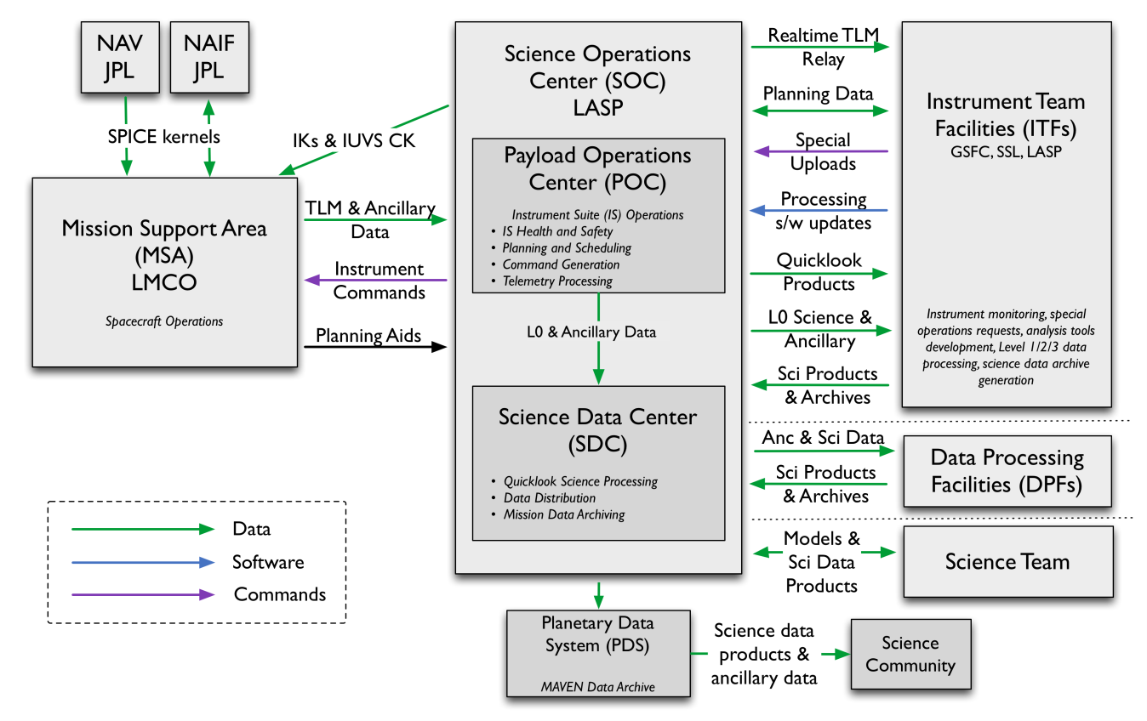
Figure 14: MAVEN Ground Data System responsibilities and data flow. Note that this figure includes portions of the MAVEN GDS which are not directly connected with archiving, and are therefore not described in Section 3.5 above.

Archive Generation
The SWEA archive products are produced by the SWEA team in cooperation with the SDC, and with the support of the PDS Planetary Plasma Interactions (PPI) Node at the University of California, Los Angeles (UCLA). The archive volume creation process described in this section sets out the roles and responsibilities of each of these groups. The assignment of tasks has been agreed upon by all parties. Archived data received by the PPI Node from the SWEA team are made available to PDS users electronically as soon as practicable but no later two weeks after the delivery and validation of the data.

Data Processing and Production Pipeline
The following sections describe the process by which data products in the SWEA bundle listed in Table 10 are produced. All levels refer to MAVEN processing levels (Table 8).

Raw Data Production Pipeline
After receiving Level 0 data from the POC, the SDC will process the Level 0 into Quicklook science products using software provided by the SWEA ITF. The SDC will provide the SWEA ITF with Level 0 data files (consisting of compressed PF packets in their native format, one file per UT day for all PF Survey data, and one file per UT day for all PF Archive data), Quicklook science data, and all ancillary data required for science processing. From these data, the SWEA ITF will generate Level 2 calibrated science data products. The science data products that the SWEA ITF delivers to the SDC will be stored by the SDC for the duration of the project, and will be made available to the MAVEN team. The SDC will deliver archival-quality science data products to the PDS for distribution to the public and long-term archiving in accordance with the SWEA-PDS SIS (this document) and the SOC-PDS SIS. The SDC will also be responsible for delivering Level 0 archives and non-SPICE ancillary data to the PDS for long-term archiving, in accordance with the SOC-PDS SIS and the Export Control Checklist.

Calibrated Data Production Pipeline
Calibrated SWEA Level 2 data will be produced from the raw level 0 PF data files by the SWEA ITF using IDL software, and provided for archiving in the PDS in CDF format. The data production pipeline will be run in an automated fashion to produce archival-ready files from the raw level 0 data.
Beginning as soon as possible but no later than 2 months after the start of science operations, the SWEA ITF will routinely generate Level 2 science data products and deliver them to the SOC. After the initial 2-month calibration period, the SWEA ITF will deliver preliminary Level 2 products to the SDC for distribution to the MAVEN team within two weeks of receiving all data required for science processing (including all SPICE kernels and other ancillary data required for processing) by the ITFs. Final Level 2 SWEA products will be delivered to the SDC as soon as they are complete, no later than needed to meet the PDS delivery schedule in Table 12.
The SWEA ITF does not plan to produce Level 3 products, instead using Level 2 as the final science products.
The SWEA ITF will deliver validated science data products and associated metadata for PDS archiving to the SOC two weeks prior to every PDS delivery deadline. The first PDS delivery will occur no later than 6 months after the start of science operations, and subsequent deliveries will take place every 3 months after the first delivery. The first delivery will include data collected during the cruise and transition phases in addition to the science data from the first 3 months of the mapping phase. Each subsequent delivery will contain data from the 3 months following the previous delivery. The final delivery may contain products involving data from the entire mission.
The SWEA ITF will also provide the SDC with data product descriptions, appropriate for use by the MAVEN science team in using MAVEN science data products and consistent with PDS metadata standards.

Data Validation

Instrument Team Validation
All SWEA data will be calibrated and converted to physical units by the SWEA ITF, then spot-checked by the instrument lead and his designees for accuracy and integrity.

MAVEN Science Team Validation
The MAVEN science team will work with the same SWEA products that will be archived in the PDS. If any calibration issues or other anomalies are noted, they will be addressed at the SWEA ITF by the instrument lead or his designees.

PDS Peer Review
The PPI node will conduct a full peer review of all of the data types that the SWEA team intends to archive. The review data will consist of fully formed bundles populated with candidate final versions of the data and other products and the associated metadata.

Table 11: MAVEN PDS review schedule
Date | Activity | Responsible Team
2014-Mar-24 | Signed SIS deadline | ITF
2014-Apr-18 | Sample data products due | ITF
2014-May  to  2014-Aug | Preliminary PDS Peer Review (SIS, sample data files) | PDS
2015-Mar-02 | Release #1: Data due to PDS | ITF/SDC
2014-Mar  to  2015-Apr | Release #1: Data PDS Peer Review | PDS
2015-May-01 | Release #1: Public release | PDS

Reviews will include a preliminary delivery of sample products for validation and comment by PDS PPI and Engineering node personnel. The data provider will then address the comments coming out of the preliminary review, and generate a full archive delivery to be used for the peer review.
Reviewers will include MAVEN Project and SWEA team representatives, researchers from outside of the MAVEN project, and PDS personnel from the Engineering and PPI nodes. Reviewers will examine the sample data products to determine whether the data meet the stated science objectives of the instrument and the needs of the scientific community and to verify that the accompanying metadata are accurate and complete. The peer review committee will identify any liens on the data that must be resolved before the data can be ‘certified’ by PDS, a process by which data are made public as minor errors are corrected.
In addition to verifying the validity of the review data, this review will be used to verify that the data production pipeline by which the archive products are generated is robust. Additional deliveries made using this same pipeline will be validated at the PPI node, but will not require additional external review.
As expertise with the instrument and data develops the SWEA team may decide that changes to the structure or content of its archive products are warranted. Any changes to the archive products or to the data production pipeline will require an additional round of review to verify that the revised products still meet the original scientific and archival requirements or whether those criteria have been appropriately modified. Whether subsequent reviews require external reviewers will be decided on a case-by-case basis and will depend upon the nature of the changes. A comprehensive record of modifications to the archive structure and content is kept in the Modification_History element of the collection and bundle products.
The instrument team and other researchers are encouraged to archive additional SWEA products that cover specific observations or data-taking activities. The schedule and structure of any additional archives are not covered by this document and should be worked out with the PPI node.

Data Transfer Methods and Delivery Schedule
The SOC is responsible for delivering data products to the PDS for long-term archiving. While ITFs are primarily responsible for the design and generation of calibrated and derived data archives, the archival process is managed by the SOC. The SOC (in coordination with the ITFs) will also be primarily responsible for the design and generation of the raw data archive. The first PDS delivery will take place within 6 months of the start of science operations. Additional deliveries will occur every following 3 months and one final delivery will be made after the end of the mission. Science data are delivered to the PDS within 6 months of its collection. If it becomes necessary to reprocess data which have already been delivered to the archive, the ITFs will reprocess the data and deliver them to the SDC for inclusion in the next archive delivery. A summary of this schedule is provided in Table 12 below.

Table 12: Archive bundle delivery schedule
Bundle Logical Identifier | First Delivery to PDS | Delivery Schedule | Estimated Delivery Size
urn:nasa:pds:maven.swea.calibrated | No later than 6 months after the start of science operations | Every 3 months | 11.8 GB

Each delivery will comprise both data and ancillary data files organized into directory structures consistent with the archive design described in Section 5, and combined into a deliverable file(s) using file archive and compression software. When these files are unpacked at the PPI Node in the appropriate location, the constituent files will be organized into the archive structure.
Archive deliveries are made in the form of a “delivery package”. Delivery packages include all of the data being transferred along with a transfer manifest, which helps to identify all of the products included in the delivery, and a checksum manifest which helps to insure that integrity of the data is maintained through the delivery. The format of these files is described in Section 6.4.
Data are transferred electronically (using the ssh protocol) from the SOC to an agreed upon location within the PPI file system. PPI will provide the SOC a user account for this purpose. Each delivery package is made in the form of a compressed tar or zip archive. Only those files that have changed since the last delivery are included. The PPI operator will decompress the data, and verify that the archive is complete using the transfer and MD5 checksum manifests that were included in the delivery package. Archive delivery status will be tracked using a system defined by the PPI node.
Following receipt of a data delivery, PPI will reorganize the data into its PDS archive structure within its online data system. PPI will also update any of the required files associated with a PDS archive as necessitated by the data reorganization. Newly delivered data are made available publicly through the PPI online system once accompanying labels and other documentation have been validated. It is anticipated that this validation process will require no more than fourteen working days from receipt of the data by PPI. However, the first few data deliveries may require more time for the PPI Node to process before the data are made publicly available.
The MAVEN prime mission begins approximately 5 weeks following MOI and lasts for 1 Earth-year. Table 12 shows the data delivery schedule for the entire mission.

Data Product and Archive Volume Size Estimates
SWEA data products consist of files that span one UT day, breaking at 0h UTC SCET. Files vary in size depending on the telemetry rate and allocation.

Data Validation
Routine data deliveries to the PDS are validated at the PPI node to ensure that the delivery meets PDS standards, and that the data conform to the SIS as approved in the peer review. As long as there are no changes to the data product formats, or data production pipeline, no additional external review will be conducted.

Backups and duplicates
The PPI Node keeps three copies of each archive product. One copy is the primary online archive copy, another is an onsite backup copy, and the final copy is an off-site backup copy. Once the archive products are fully validated and approved for inclusion in the archive, copies of the products are sent to the National Space Science Data Center (NSSDC) for long-term archive in a NASA-approved deep-storage facility. The PPI Node may maintain additional copies of the archive products, either on or off-site as deemed necessary. The process for the dissemination and preservation of SWEA data is illustrated in Figure 15.
MAVEN SWEA ITF
Deep Archive (NSSDC)
PDS Planetary Plasma Interactions (PDS-PPI) Node
Peer Review
Committee
PDS-PPI Node Mirror Site
Data Users
PDS-PPI Public Web Pages
Review Data
Validation Report
Archive Delivery
Delivery Receipt
Backup Copy
Archive Assurance
Validated Data
Figure 15: Duplication and dissemination of SWEA archive products at PDS/PPI.

Archive organization and naming
This section describes the basic organization of an SWEA bundle, and the naming conventions used for the product logical identifiers, and bundle, collection, and basic product filenames.

Logical Identifiers
Every product in PDS is assigned an identifier which allows it to be uniquely identified across the system. This identifier is referred to as a Logical Identifier or LID. A LIDVID (Versioned Logical Identifier) includes product version information, and allows different versions of a specific product to be referenced uniquely. A product’s LID and VID are defined as separate attributes in the product label. LIDs and VIDs are assigned by the entity generating the labels and are formed according to the conventions described in sections 5.1.1 and 5.1.2 below. The uniqueness of a product’s LIDVID may be verified using the PDS Registry and Harvest tools.

LID Formation
LIDs take the form of a Uniform Resource Name (URN). LIDs are restricted to ASCII lower case letters, digits, dash, underscore, and period. Colons are also used, but only to separate prescribed components of the LID. Within one of these prescribed components dash, underscore, or period are used as separators. LIDs are limited in length to 255 characters.
MAVEN SWEA LIDs are formed according to the following conventions:
- Bundle LIDs are formed by appending a bundle specific ID to the MAVEN SWEA base ID:
urn:nasa:pds:maven.swea.<bundle ID>
Since all PDS bundle LIDs are constructed this way, the combination of maven.swea.bundle must be unique across all products archived with the PDS.
- Collection LIDs are formed by appending a collection specific ID to the collection’s parent bundle LID:
urn:nasa:pds:maven.swea.<bundle ID>:<collection ID>
Since the collection LID is based on the bundle LID, which is unique across PDS, the only additional condition is that the collection ID must be unique across the bundle. Collection IDs correspond to the collection type (e.g. “browse”, “data”, “document”, etc.). Additional descriptive information may be appended to the collection type (e.g. “data-raw”, “data-calibrated”, etc.) to insure that multiple collections of the same type within a single bundle have unique LIDs.
- Basic product LIDs are formed by appending a product specific ID to the product’s parent collection LID:
urn:nasa:pds:maven.swea.<bundle ID>:<collection ID>:<product ID>
Since the product LID is based on the collection LID, which is unique across PDS, the only additional condition is that the product ID must be unique across the collection.

A list of SWEA bundle LIDs is provided in Table 10. Collection LIDs are listed in Table 13.

VID Formation
Product version ID’s consist of major and minor components separated by a “.” (M.n). Both components of the VID are integer values. The major component is initialized to a value of “1”, and the minor component is initialized to a value of “0”. The minor component resets to “0” when the major component is incremented.

SWEA Archive Contents
The SWEA archive includes the calibrated (MAVEN Level 2) bundle listed in Table 10. The following sections describe the contents of each of these bundles in greater detail.

SWEA Calibrated (MAVEN Level 2) Science Data Bundle
The swea.calibrated Level 2 Science Data Bundle contains fully calibrated data in physical units, consisting of energy/angle (3D) distributions, pitch angle distributions (PADs), and omni-directional energy spectra.

Table 13 swea.calibrated Level 2 Science Data Collections
Collection LID | Description
urn:nasa.pds:maven.swea.calibrated:data.svy_3d | Energy/angle (3D) distributions in units of differential energy flux (eV/cm² sec ster eV) from SWEA survey data
urn:nasa.pds:maven.swea.calibrated:data.arc_3d | Energy/angle (3D) distributions in units of differential energy flux (eV/cm² sec ster eV) from SWEA archive data
urn:nasa.pds:maven.swea.calibrated:data.svy_pad | Pitch angle distributions in units of differential energy flux (eV/cm² sec ster eV) from SWEA survey data
urn:nasa.pds:maven.swea.calibrated:data.arc_pad | Pitch angle distributions in units of differential energy flux (eV/cm² sec ster eV) from SWEA archive data
urn:nasa.pds:maven.swea.calibrated:data.svy_spec | Omni-directional energy spectra in units of differential energy flux (eV/cm² sec ster eV) from SWEA survey data
urn:nasa.pds:maven.swea.calibrated:data.arc_spec | Omni-directional energy spectra in units of differential energy flux (eV/cm² sec ster eV) from SWEA archive data
urn:nasa:pds:maven.swea.calibrated:document | Documents related to the swea.calibrated bundle.

swea.calibrated.svy_3d Data Collection
SWEA survey 3D collections contain files with time-ordered arrays of raw counts and fully calibrated electron energy/angle distributions in units of differential energy flux (eV/cm² sec ster eV). Ancillary information needed to interpret the data is also provided.
The data files contain a time-ordered array with three time scales: Epoch time, Mission Elapsed Time (MET) and Unix time. All times refer to the center of the accumulation interval for each data record. Epoch time is a 64-bit signed integer defined as terrestrial time with a time base of J2000 (Julian date 2451545.0 TT or 2000 January 1, 12h TT) in units of nanoseconds. This time reference, known as TT2000, accounts for leap seconds. Conversion between TT and UTC is straightforward: TT = UTC + deltaAT + 32.184s, where deltaAT is the sum of the leap seconds since 1960. Unix time is a double precision float that is the number of seconds (including fractional seconds) since 00:00:00 UTC on January 1, 1970, not counting leap seconds. MET is the same as spacecraft clock time (SCLK), except that the units of MET are seconds, and SCLK is in units of the smallest time increment of the spacecraft clock, which for MAVEN is 1/65536 sec. MET is the primary data collection reference for the entire MAVEN payload. (The 2-second SWEA data collection cycle is synchronized to MET.) A correction for spacecraft clock drift is performed when converting MET to TT2000 and Unix time.
At each time step, data are packaged into a 64-energy × 16-azimuth angle × 6-elevation angle array, with an energy binning factor (1 = 64 energies, 2 = 32 binned energies, 4 = 16 binned energies). For data with 32 or 16 binned energies, a full 64-energy data structure is provided for commonality and ease of use, but the 64 energy steps contain the binned counts duplicated B times (B = 2 or 4). For example, for a case with 16 binned energy steps (B = 4), each of the first four of the 64 energies contain the total number of counts in the first binned energy step. (Duplicated bins have an effective integration time that is B times longer than for un-duplicated bins.) The energy array contains the original 64 energies of the sweep, before any summing or duplication of counts. Thus, the effective energy of the summed bins can be computed after the fact. If the spectrum is steeply rising or falling with energy, the original distribution of counts among the summed bins would be highly non-uniform. This is a general feature of any binning scheme, whether performed by the instrument, in flight software, or on the ground. The re-binning scheme ensures that moments or other sums computed from binned data still come out right, and use of 3D data with different binning schemes is transparent to the end user. However, case must be taken when calculating statistical uncertainties, since duplicated bins are not independent.
The data files contain a 64-element list of energies, a 64×6-element array of elevation angles, a 64×6-element array of relative elevation sensitivities, a 16-element array of azimuth angles, a 16-element array of relative anode sensitivities, and an integration time, for use with the 3D data products. The files also contain the energy resolution of the sweep tables and the full sensor geometric factor. All of these support data are stored as NOVARY records, meaning they are the same for all times in the file.
To convert between raw counts and differential energy flux, first calculate the raw count rate per anode:

$$\text{R}'=\frac{\text{COUNTS}}{\text{BINNING × ACCUM_TIME}}$$

The BINNING term accounts for the summing of adjacent energy channels. For the 3D data product, this term must be multiplied by an additional factor of 2 at the highest positive and negative elevations to account for the summing of adjacent azimuth sectors at those elevations. This applies to the 3D data product only.
Next, correct for dead time:

$$R=R'{(1-R^{'}τ)}^{-1}$$

where τ = 2.8 × 10⁻⁶ sec is the dead time for one of the 16 MCP-anode-preamp chains. Data are flagged as bad whenever R' > 0.8/τ.
Finally, convert to differential energy flux (eV/cm²-sec-ster-eV):

$$\text{DIFF_EN_FLUX}=\frac{\text{R}}{\text{GEOM_FACTOR × G_ENGY × G_AZIM × G_ELEV}}$$

The terms in the denominator are as follows:
GEOM_FACTOR: The geometric factor per anode sector from ground calibrations with a beam energy of 1.4 keV and V₀ disabled (inner toroidal grid held at ground throughout the sweep). This calibration was performed on the fully assembled analyzer, so it includes the overall MCP efficiency at 1.4 keV (typically ~75%). Units are cm²-ster-eV/eV.
G_ENGY: Sensitivity variation with energy. This is composed of two multiplicative terms. The first is variation of the MCP efficiency with energy (Goruganthu and Wilson, Rev. Sci. Instr. 55, 2030, 1984), and the second is variation of the geometric factor with energy when using the V₀ operation mode (see Section 2). Dimensionless. When V₀ is disabled, G_ENGY is normalized to unity at 1.4 keV.
G_AZIM: Sensitivity variation with azimuth due to MCP efficiency variations and geometric blockage from support ribs. Dimensionless; average normalized to unity.
G_ELEV: Sensitivity variation with elevation (mostly due to optics). Dimensionless; average normalized to unity.
When energy and/or azimuth bins are duplicated, the linear average of G_ENGY and/or G_AZIM is recorded for each group of duplicated values. All 64 energies are always recorded in ENERGY with no averaging. The BINNING factor can be used to determine the energies of the bins that have been summed.
The 3D product provides the most information, but with a low cadence (16 or 32 sec, depending on altitude, 8 sec for burst) because of the amount of telemetry it consumes. To reduce the total data volume, the PAD and SPEC products are extracted from the 3D product onboard by sampling and/or averaging. All three data products are synchronized, so the 3D product can be used to verify the other two. The 3D data product can be compared with the SPEC data product by summing over the 96 solid angle bins, each weighted by solid angle, and then dividing by the total solid angle subtended by the FOV, thus maintaining units of eV/cm²-sec-ster-eV (see Section 2.3.3). The 3D product can be used to make additional corrections, such as transforming to the plasma rest frame, which would not be possible with the SPEC product alone. In addition, 3D distributions can be used to investigate the effects of the spacecraft environment on the measurements. For example, the spacecraft photoelectron population can be imaged at energies below the spacecraft potential. This distribution is anisotropic and depends on the illumination pattern of the spacecraft.
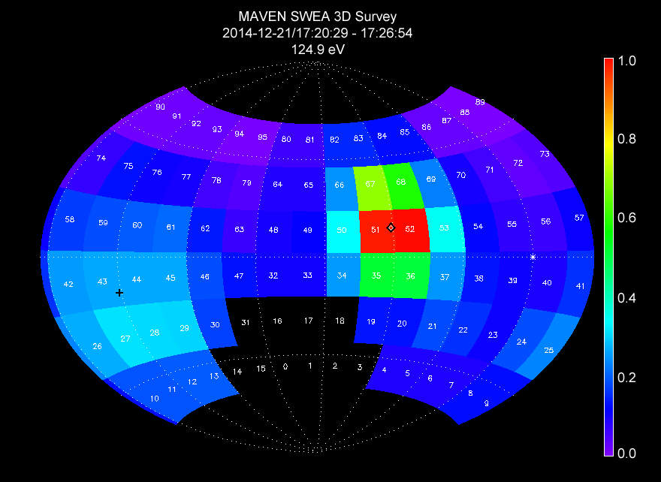
Figure 16: SWEA 3D data product showing the angular distribution of 125-eV electrons in the solar wind. The data are normalized to unity at the peak energy flux, and relative variations are shown with a linear color scale. The data are mapped in SWEA science coordinates over the full sky with an Aitoff projection, and each azimuth-elevation bin is labeled with its bin number (0-95). The instrument's blind spots (|elevation| > 60°) and bins blocked by the spacecraft have no color. The magnetic field direction is indicated by the plus (+B) and diamond (−B) symbols.

Figure 16 shows an example of the 3D data product, summed over a 6.4-minute interval during which the magnetic field direction was nearly constant. This distribution was measured in the solar wind, upstream of the Mars bow shock, at an altitude of 6100 km. At an energy of 125 eV (shown here), the distribution is dominated by the solar wind halo population, which is typically beamed away from the Sun along the interplanetary magnetic field. This beam can be seen clearly in the angular distribution centered on the –B direction. Ten of the 96 solid angle bins are masked because of spacecraft blockage. Since the spacecraft is fixed in SWEA's field of view, the same bins (0-3, 14-18, and 31) are always marked as invalid in the 3D data product. Figure 16 represents only one of the 32 (binned) energy channels that make up this 3D data product.
MAVEN Magnetometer (MAG) data are provided in three coordinate frames: payload (PL), sun-state (SS), and planetocentric (PC). Payload coordinates are defined in Fig. 2. To transform the magnetic field vector from payload to SWEA coordinates, rotate about the Z axis by 140 degrees (see Fig. 2b).

$$B_{SWEA}=\left[\begin{matrix}\cos{140°} & \sin{140°} & 0 \\ -\sin{140°} & \cos{140°} & 0 \\ 0 & 0 & 1\end{matrix}\right] B_{PL}$$

MAG Level 2 data were averaged over the time interval spanned by the 3D distribution shown in Fig. 16, rotated to the SWEA frame, and plotted with plus (+B) and diamond (−B) symbols. This direction can differ from that provided in the PAD data product (B_AZIM, B_ELEV), because the onboard calculation does not include the full calibration.
The SWEA ITF will produce these products, with one file per UT day, with the naming convention mvn_swe_l2_svy3d_<YYYY><MM><DD>_v<xx>_r<yy>.cdf, where:
<YYYY> = Four digit year.
<MM> = Two digit month (e.g., 01, 12).
<DD> = Two digit day of month (e.g., 01, 31).
v<xx> = Major revision number. This number changes with a significant change in the processing algorithm or instrument calibration parameters. Typically, a change in major revision triggers a reprocessing of the entire data set. Changes to the major revision are controlled by the corresponding instrument lead and are documented.
r<yy> = Minor revision number. This number changes whenever the data are regenerated without a change to the major revision. This can occur for a variety of reasons, typically to fill in missing science data or to apply new or updated ancillary data, such as SPICE kernels.
The complete file naming convention (Appendix B) includes optional fields, which are not used by SWEA. All data records have time tags between 00:00:00 and 23:59:59 (or 23:59:60 if on a leap second) of the date specified. All time tags correspond to the center of the accumulation interval.

swea.calibrated.arc_3d Data Collection
SWEA archive 3D collections are identical to SWEA survey 3D collections, as described in the previous section. The only difference is the naming convention:
mvn_swe_l2_arc3d_<YYYY><MM><DD>_v<xx>_r<yy>.cdf
Archive data have higher energy and/or time resolution, but for limited spans of time.

swea.calibrated.svy_pad Data Collection
SWEA survey PAD collections contain files with time-ordered fully calibrated electron pitch angle distributions in units of differential energy flux (eV/cm² sec ster eV) derived from the SWEA PAD survey telemetry, as well as a header of ancillary information needed to interpret the data.
The data files contain a time-ordered array with time in Epoch time, Mission-Elapsed-Time (MET) and Unix time (Seconds since 1970-01-01/00:00), a 64-energy × 16-pitch angle array of data, and the energy binning factor (1 = 64 energies, 2 = 32 binned energies, 4 = 16 binned energies) at each time step.
For data with 32 or 16 binned energies, a full 64-energy data structure is provided for commonality and ease of use, but the 64 energy steps contain the binned counts duplicated B times (B = 2 or 4). For example, for a case with 16 binned energy steps (B = 4), each of the first four steps of the 64 energies contain the number of counts in the first binned energy step. (Duplicated bins have an effective integration time that is B times longer than for un-duplicated bins.) This re-binning scheme ensures that use of PAD data with different binning schemes is transparent to the end user. However, case must be taken when calculating statistical uncertainties, since duplicated bins are not independent.
The mapping of pitch angle around the field of view varies with time as the magnetic field direction changes. For each PAD measurement, flight software applies a nominal calibration (fixed gains and offsets) to the raw magnetic field data and estimates the magnetic field direction in SWEA instrument coordinates. With this information, it determines the optimal 2D cut (great circle) through the 3D distribution that includes the magnetic field direction, or comes as close as possible to doing so while staying entirely within the instrument's field of view. The PAD data files contain the magnetic field azimuth and elevation (B_AZIM, B_ELEV), in instrument coordinates, used by flight software to perform this calculation.
Each of the 16 pitch angle bins in the PAD data product maps directly into one of the 96 solid angle bins in the 3D data product, without averaging or interpolation. Consequently, the pitch angle map can be refined in ground processing using fully calibrated Level 2 Magnetometer data. The data files contain a 64×16-element array of pitch angles (PA) and a 64×16-element array of pitch angle ranges (D_PA; full width centered at each pitch angle) that are calculated from Level 2 Magnetometer data, as well as relative sensitivity variations in azimuth and elevation as mapped into pitch angle (G_PA). All of these vary with time.
The files also contain support data that do not vary with time: 64-element arrays of bin energies (ENERGY) and energy resolution (ΔE/E, FWHM), the geometric factor per anode sector measured at 1.4 keV (GEOM_FACTOR), and a 64-element array that provides relative sensitivity variations with energy (G_ENGY). Finally, the files contain the accumulation time per sample. All of these support data are stored as /novary records in the CDF files.
To convert between raw counts and differential energy flux, use the same procedure as for the 3D distributions, except the product (G_AZIM × G_ELEV) is replaced by G_PA. There is no summing of azimuth bins at high elevations for the PAD data product, so only the energy binning factor applies.
Figure 17 shows an electron pitch angle distribution measured over the same time interval as the 3D distribution in Fig. 16. Because SWEA has 360-degree coverage in azimuth, the 0-180-degree pitch angle distribution is measured twice. The field-aligned beam appears in the pitch angle distribution as an increased flux from ~135 to 180 degrees.

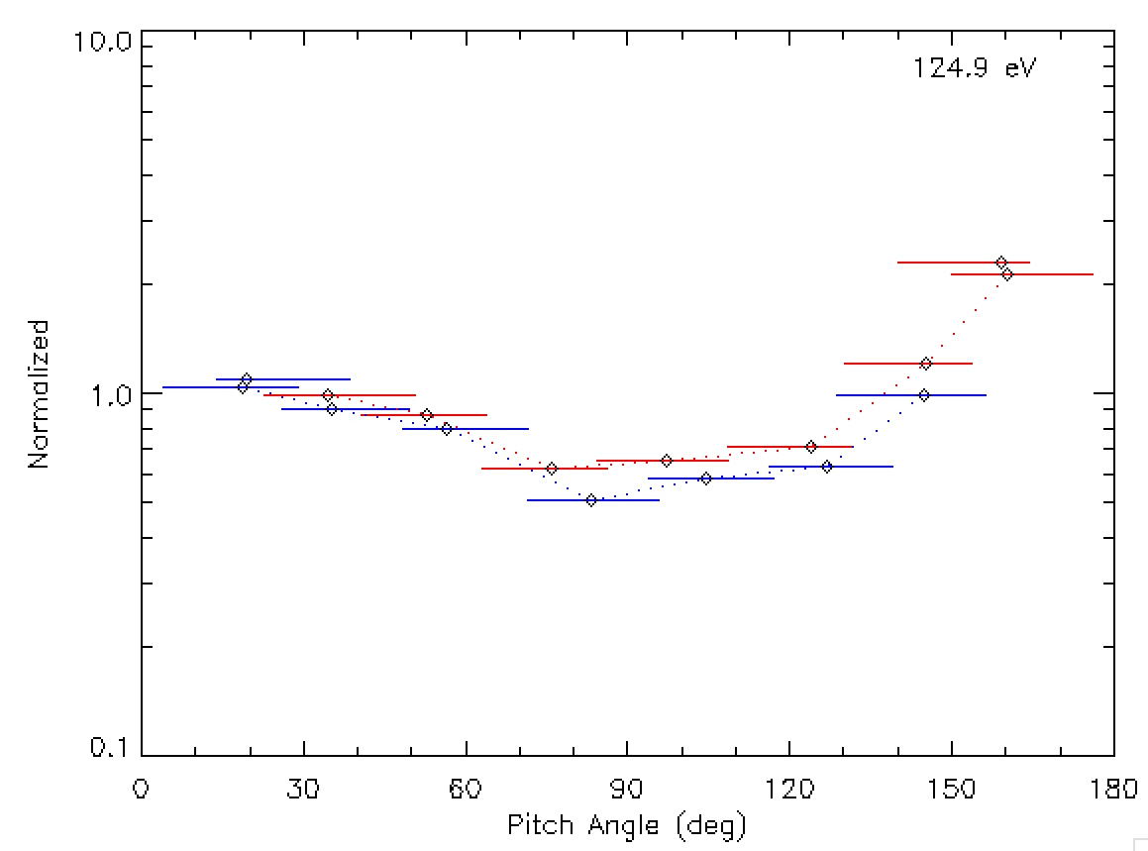
Figure 17: Electron pitch angle distribution measured in the solar wind over the same time interval in Fig. 16. The distribution is measured twice (blue and red), and the pitch angle coverage of each bin is indicated by the horizontal bar. This cut through the 3D distribution does not intersect the spacecraft, so all 16 pitch angle bins represent valid measurements. When a cut does include 3D bins that are blocked by the spacecraft, those bins are flagged as invalid in the PAD data.

The SWEA ITF will produce these products, with one file per UT day, with the naming convention mvn_swe_l2_svypad_<YYYY><MM><DD>_v<xx>_r<yy>.cdf

swea.calibrated.arc_pad Data Collection
SWEA archive PAD collections are identical to SWEA survey PAD collections, as described in the previous section. The only difference is the naming convention:
mvn_swe_l2_arcpad_<YYYY><MM><DD>_v<xx>_r<yy>.cdf
Archive data have higher energy and/or time resolution, but for limited spans of time.

swea.calibrated.svy_spec Data Collection
SWEA survey SPEC collections contain files with time-ordered angle-averaged electron energy spectra in units of differential energy flux (eV/cm² sec ster eV), as well as a header with ancillary information needed to interpret the spectra.
The data files contain a time-ordered array with time in Epoch time, Mission-Elapsed-Time (MET) and Unix time (Seconds since 1970-01-01/00:00), a 64-element array of angle-averaged differential energy fluxes, and the number of accumulations used to compute the spectra, at each time step.
The data files also contain a 64-element list of energies, and the intrinsic energy resolution of the sweep table, integration time, and geometric factor per anode measured at 1.4 keV. In addition, a weighting factor is included to convert raw counts to raw count rate. All of these support data are stored as /novary records in the CDF files.
To convert between raw counts and differential energy flux, first calculate the raw count rate:

$${\text{R}}^{'}=\frac{\text{COUNTS}}{\text{WEIGHT_FACTOR × NUM_ACCUM × ACCUM_TIME}}$$

Since counts are summed over all 16 azimuth and 6 elevation bins, the effective accumulation time is 16×6×4×1.09 msec = 0.418 sec. The term WEIGHT_FACTOR is the average of the six cosθ factors that multiply the raw counts as they are summed onboard (see Section 2.3.3). The term NUM_ACCUM is the number of 2-second accumulations summed per energy spectrum. In sample mode, energy spectra are sampled every 2^{N} seconds (N = 1, 2, …), and NUM_ACCUM is always unity. In sum mode, energy spectra are summed over 2^{N}-second intervals, and NUM_ACCUM = 2^{N − 1}. This results in a weighted raw count rate per sector (R').
Next, correct for dead time:

$$R=R'{(1-R^{'}τ)}^{-1}$$

Finally, convert to differential energy flux (eV/cm²-sec-ster-eV):

$$\text{DIFF_EN_FLUX}=\frac{\text{R}}{\text{GEOM_FACTOR × G_ENGY}}$$

The terms in the denominator are as follows:
GEOM_FACTOR: The geometric factor per anode sector from ground calibrations with a beam energy of 1.4 keV and V₀ disabled (inner toroidal grid held at ground throughout the sweep). This calibration was performed on the fully assembled analyzer, so it includes the overall MCP efficiency at 1.4 keV (typically ~75%). Units are cm²-ster-eV/eV.
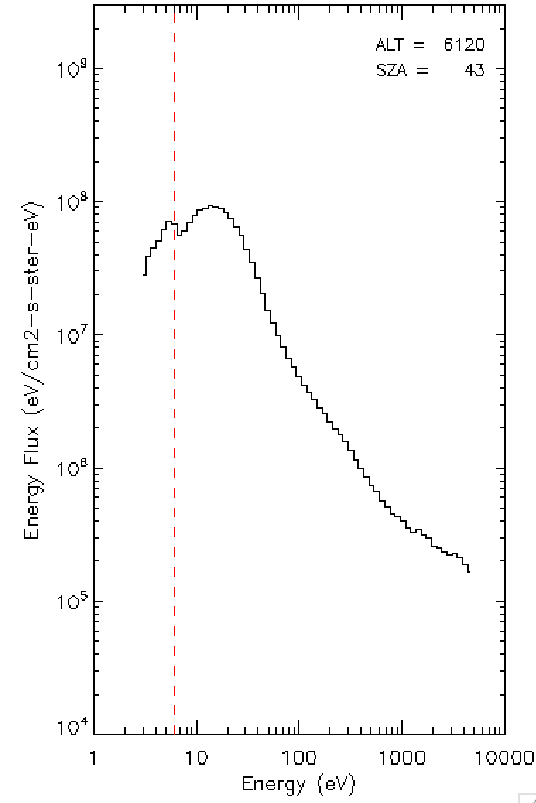
G_ENGY: Sensitivity variation with energy. This is composed of two multiplicative terms. The first is variation of the MCP efficiency with energy (Goruganthu and Wilson, Rev. Sci. Instr. 55, 2030, 1984), and the second is variation of the geometric factor with energy when using the V₀ operation mode (see Section 2). Dimensionless. When V₀ is disabled, G_ENGY is normalized to unity at 1.4 keV.
Figure 18: Electron energy distribution measured in the solar wind. The 64 energy channels are logarithmically spaced from 3 eV to 4.6 keV, with a sampling in energy (12%) that is finer than the instrument's intrinsic energy resolution of 17% (ΔE/E, FWHM) The vertical dashed line is an estimate of the spacecraft potential (see text).
Figure 18 shows an electron energy distribution obtained over the same time interval as in Figs. 16 and 17. The spacecraft potential (+6 Volts, vertical dashed line) can often be identified by a sharp break in the energy distribution. At energies below this potential, SWEA measures spacecraft photoelectrons that have insufficient energy to escape, and are thus attracted back to the spacecraft. At higher energies, SWEA measures ambient solar wind electrons, shifted in energy by the amount of the spacecraft potential.
Removal of spacecraft photoelectrons and correction for spacecraft potential are critical for estimating density and temperature from the measured electron distributions (see the chapter by McFadden et al., in Calibration of Particle Instruments in Space Physics, Martin Wuest, David S. Evans, Rudolf von Steiger (eds.), ISSI Scientific Reports Series, p. 277-385, 2007). For example, to estimate electron number density (n_{e}) from the measured energy flux, we sum over energy and angle:

$$n_{e}={\left(\frac{m_{e}}{2}\right)}^{1/2} \sum_{Ω^{'}}{ }\sum_{E^{'}>φ}{{\left(1-φ/E^{'}\right)}^{1/2}}{\left(E^{'}\right)}^{-3/2} F^{'}(E^{'},Ω^{'}) ΔE^{'} ΔΩ^{'}$$

where E', F', and Ω' are the energy, energy flux, and solid angle as measured in the instrument frame (for SWEA, just outside the outer toroidal grid); φ is the spacecraft potential, and m_{e} is the electron mass. The solid angle spanned by each angular bin is:
$$\text{∆Ω}\text{'}\text{ = 2 }\text{Δ}\text{ϕ}\text{'}\text{ sin}\left(\frac{\text{∆}\text{θ}\text{'}}{\text{2}} \right)\text{ cos}\text{θ}\text{'}$$
where Δϕ' and Δθ' are the angular widths in azimuth (22.5°) and elevation (20°), and θ' is the center elevation. For the SPEC data product, the summation over angle is performed onboard with cosθ weighting factors, as described above. For the 3D data product, angular summation is performed on the ground. In this case, further corrections can be made for plasma bulk flow velocity relative to the spacecraft.
The summation over energy is carried out only over energy channels above the spacecraft potential. Since SWEA does not measure the distribution over the full sky, this sum is multiplied by a correction factor (4π/ΣΔΩ) to account for the part of the distribution that is not measured, under the assumption that the distribution in the instrument's blind spots is not very different from the part of the distribution that is measured.
The SWEA ITF will produce these products, with one file per UT day, with the naming convention: mvn_swe_l2_svyspec_<YYYY><MM><DD>_v<xx>_r<yy>.cdf

swea.calibrated.arc_spec Data Collection
SWEA archive SPEC collections are identical to SWEA survey SPEC collections, as described in the previous section. The only difference is the naming convention:
mvn_swe_l2_arcspec_<YYYY><MM><DD>_v<xx>_r<yy>.cdf
Archive data have higher time resolution, but for limited spans of time. This data product was designed before launch to be used only when the science telemetry bandwidth, which varies with the Earth-Mars distance, is small. However, the actual telemetry bandwidth is higher than pre-launch estimates, so we do not anticipate producing this product.

swea.calibrated Document Collection
The SWEA calibrated data document collection contains documents which are useful for understanding and using the SWEA Calibrated (MAVEN Level 2) Science Data bundle. Table 14 contains a list of the documents included in this collection, along with the LID, and responsible group. Following this a brief description of each document is also provided.

Table 14: SWEA Calibrated Science Data Documents
Document Name | LID | Responsiblility
MAVEN Science Data Management Plan | urn:nasa:pds:maven:document:sdmp | MAVEN Project
MAVEN SWEA Archive SIS | urn:nasa:pds:maven.swea:document:SIS | SWEA Team
MAVEN SWEA Instrument Paper | urn:nasa:pds:maven.swea:document: swea.instpaper | SWEA Team

MAVEN Science Data Management Plan – describes the data requirements for the MAVEN mission and the plan by which the MAVEN data system will meet those requirements
MAVEN SWEA Archive SIS – describes the format and content of the SWEA PDS data archive, including descriptions of the data products and associated metadata, and the archive format, content, and generation pipeline (this document)
SWEA Instrument Paper – describes the instrument operation and data products.
While responsibility for the individual documents varies, the document collection itself is managed by the PDS/PPI node.

Archive product formats
Data that comprise the SWEA archives are formatted in accordance with PDS specifications [see Planetary Science Data Dictionary [4], PDS Data Provider’s Handbook [2], and PDS Standards Reference [3]. This section provides details on the formats used for each of the products included in the archive.

Data File Formats
This section describes the format and record structure of each of the data file types.

Calibrated data file structure
SWEA calibrated data files will be archived with PDS as Common Data Format (CDF). In order to allow the archival CDF files to be described by PDS metadata a number of requirements have been agreed to between the SWEA ITF and the PDS-PPI node. An early version of these requirements are detailed in the document Archive of MAVEN CDF in PDS4 (T. King and J. Mafi, July 16, 2013). All parties will agree upon the final requirements before sample files are produced. These CDF files will be the same ones used and distributed by the SWEA ITF internally. The contents of the SWEA CDF files are described in the tables below.

Table 15 Contents for swea.calibrated.svy_3d and swea.calibrated.arc_3d data files
Field Name | Data Type | Description
EPOCH | TT2000  (64-bit signed integer) | UTC time from 01-Jan-2000 12:00:00.000 including leap seconds, one element per 3D distribution (NUM_DISTS elements)
TIME_MET | DOUBLE  (64-bit float) | Mission elapsed time (spacecraft clock or SCLK in SPICE terms) for this data record, one element per 3D distribution (NUM_DISTS elements)
TIME_UNIX | DOUBLE  (64-bit float) | Unix time (elapsed seconds since 1970-01-01/00:00 without leap seconds) for this data record, one element per 3D distribution (NUM_DISTS elements)
BINNING | INTEGER  (8-bit signed integer) | Energy binning factor, B (1 = 64 energies, 2 = 32 energies, 4 = 16 energies), one element per 3D distribution (NUM_DISTS elements). Duplicated bins have an effective integration time that is B times longer than for unduplicated bins. At the highest positive and negative elevations, this binning factor must be multiplied by 2 to account for the summing of adjacent azimuth bins.
COUNTS | FLOAT  (32-bit float) | 64×16×6-element array of 3D product counts, one array per 3D distribution (NUM_DISTS×64×16×6 elements). When adjacent energy and/or azimuth bins are summed, the raw counts are duplicated among the summed bins, and the binning factor is used to renormalize when computing count rate.
DIFF_EN_FLUXES | FLOAT  (32-bit float) | 64×16×6-element array of differential energy fluxes [eV/(cm² s sr eV)] computed from the COUNTS array, as described above.
GEOM_FACTOR | FLOAT (NOVARY)  (32-bit float) | Geometric factor per anode [cm² s sr eV/eV] measured at 1.4 keV. This includes a factor for the overall MCP efficiency at 1.4 keV.
G_ENGY | FLOAT (NOVARY)  (32-bit float) | 64-element array of relative sensitivity as a function of energy. This accounts for the energy dependence of the MCP efficiency, as well as the effects of using V₀.
DE_OVER_E | FLOAT (NOVARY)  (32-bit float) | 64-element array of energy resolution (FWHM) as a function of energy.
ACCUM_TIME | FLOAT (NOVARY)  (32-bit float) | Accumulation time for each sample, nominally 4×1.09 msec to account for the summation over 4 deflection steps for each element of the telemetry product that is used to make the 3D distributions.
ENERGY | FLOAT (NOVARY)  (32-bit float) | 64-element array of energies (eV) covered by the distribution. All 64 energies are provided, even when B = 2 or 4.
ELEV | FLOAT (NOVARY)  (32-bit float) | 64×6-element array of elevation angles (instrument coordinates) covered by the distribution
G_ELEV | FLOAT (NOVARY)  (32-bit float) | 64×6-element array of relative sensitivity as a function of elevation. Average normalized to unity.
AZIM | FLOAT (NOVARY)  (32-bit float) | 16-element array of azimuth angles (instrument coordinates)
G_AZIM | FLOAT (NOVARY)  (32-bit float) | 16-element array of relative sensitivity as a function of azimuth. Average normalized to unity.
NUM_DISTS | INTEGER (NOVARY)  (32-bit signed integer) | Number of 3D distributions in the file

Table 16 Contents for swea.calibrated.svy_pad and swea.calibrated.arc_pad data files
Field Name | Data Type | Description
EPOCH | TT2000  (64-bit signed integer) | UTC time from 01-Jan-2000 12:00:00.000 including leap seconds, one element per PAD (NUM_DISTS elements)
TIME_MET | DOUBLE  (64-bit float) | Mission elapsed time (spacecraft clock or SCLK in SPICE terms) for this data record, one element per PAD (NUM_DISTS elements)
TIME_UNIX | DOUBLE  (64-bit float) | Unix time (elapsed seconds since 1970-01-01/00:00 without leap seconds) for this data record, one element per PAD (NUM_DISTS elements)
BINNING | INTEGER  (8-bit signed integer) | Energy binning factor, B (1 = 64 energies, 2 = 32 energies, 4 = 16 energies), one element per PAD (NUM_DISTS elements). Duplicated bins have an effective integration time that is B times longer than for unduplicated bins.
COUNTS | FLOAT  (32-bit float) | 64×16-element array of PAD product counts, one array per PAD distribution (NUM_DISTS×64×16 elements). When adjacent energy bins are summed, the raw counts are duplicated among the summed bins, and the binning factor is used to renormalize when computing count rate.
DIFF_EN_FLUXES | FLOAT  (32-bit float) | 64×16-element array of differential energy fluxes [eV/(cm² s sr eV)] computed from the COUNTS array, as described above.
GEOM_FACTOR | FLOAT (NOVARY)  (32-bit float) | Geometric factor per anode [cm² s sr eV/eV] measured at 1.4 keV. This includes a factor for the overall MCP efficiency at 1.4 keV.
G_ENGY | FLOAT (NOVARY)  (32-bit float) | 64-element array of relative sensitivity as a function of energy. This accounts for the energy dependence of the MCP efficiency, as well as the effects of using V₀.
DE_OVER_E | FLOAT (NOVARY)  (32-bit float) | 64-element array of energy resolution (FWHM) as a function of energy.
ACCUM_TIME | FLOAT (NOVARY)  (32-bit float) | Accumulation time for each sample, nominally 4×1.09 ms to account for the summation over 4 deflection steps for each element of the telemetry product that is used to make the PADs
ENERGY | FLOAT (NOVARY)  (32-bit float) | 64-element array of energies (eV) covered by the distribution. All 64 energies are provided, even when B = 2 or 4.
PA | FLOAT  (32-bit float) | 64×16-element array of center pitch angles covered by the distribution. This array varies with each time step as the magnetic field direction changes.
D_PA | FLOAT  (32-bit float) | 64×16-element array of pitch angle ranges (full width) spanned by each PA bin. This array varies with each time step as the magnetic field direction changes.
G_PA | FLOAT  (32-bit float) | 64×16-element array of relative sensitivity mapped into pitch angle. Each pitch angle bin maps to one of the 96 solid angle bins of the 3D distribution. The corresponding G_AZIM and G_ELEV for that solid angle bin are multiplied to produce G_PA. This array varies with each time step as the magnetic field direction changes.
B_AZIM | FLOAT  (32-bit float) | Magnetic field azimuth in instrument coord., as calculated onboard the spacecraft.
B_ELEV | FLOAT  (32-bit float) | Magnetic field elevation in instrument coord., as calculated onboard the spacecraft.
NUM_DISTS | INTEGER (NOVARY)  (32-bit signed integer) | Number of PAD distributions in the file

Table 17: Contents for swea.calibrated.svy_spec and swea.calibrated.arc_spec data files
Field Name | Data Type | Description
EPOCH | TT2000  (64-bit signed integer) | UTC time from 01-Jan-2000 12:00:00.000 including leap seconds, one element per energy spectrum (NUM_SPEC elements)
TIME_MET | DOUBLE  (64-bit float) | Mission elapsed time (spacecraft clock or SCLK in SPICE terms) for this data record, one element per energy spectrum (NUM_SPEC elements)
TIME_UNIX | DOUBLE  (64-bit float) | Unix time (elapsed seconds since 1970-01-01/00:00 without leap seconds) for this data record, one element per energy spectrum (NUM_SPEC elements)
NUM_ACCUM | INTEGER  (8-bit signed integer) | Number of two-second accumulations per energy spectrum (NUM_SPEC elements)
COUNTS | FLOAT  (32-bit float) | 64-element array of counts calculated by summing over all angles in the 3D distributions, one array per energy spectrum (NUM_SPEC×64 elements)
DIFF_EN_FLUX | FLOAT  (32-bit float) | 64-element array of differential energy fluxes [eV/(cm² s sr eV)] computed from the COUNTS array, the full sensor geometric factor GEOM_FACTOR, the accumulation time ACCUM_TIME, and the number of accumulations per distribution NUM_ACCUM, one array per energy spectrum (NUM_SPEC×64 elements)
WEIGHT_FACTOR | FLOAT (NOVARY)  (32-bit float) | Weighting factor for converting raw counts to raw count rate.
GEOM_FACTOR | FLOAT (NOVARY)  (32-bit float) | Geometric factor per anode [cm² s sr eV/eV] measured at 1.4 keV. This includes a factor for the overall MCP efficiency at 1.4 keV.
G_ENGY | FLOAT (NOVARY)  (32-bit float) | 64-element array of relative sensitivity as a function of energy. This accounts for the energy dependence of the MCP efficiency, as well as the effects of using V₀.
DE_OVER_E | FLOAT (NOVARY)  (32-bit float) | 64-element array of energy resolution (FWHM) as a function of energy
ACCUM_TIME | FLOAT (NOVARY)  (32-bit float) | Accumulation time for each sample, nominally 96×4×1.09 ms to account for the summation over 4 deflection steps for each azimuth-elevation element, then summation over the 16×6 angle elements to make the energy spectrum
ENERGY | FLOAT (NOVARY)  (32-bit float) | 64-element array of energies (eV) covered by the distribution
NUM_SPEC | INTEGER (NOVARY)  (32-bit signed integer) | Number of energy spectra in the file

Document Product File Formats
Documents are provided in either Adobe Acrobat PDF/A or plain ASCII text format. Other versions of the document (including HTML, Microsoft Word, etc.) may be included as well.

PDS Labels
PDS labels are ASCII text files written, in the eXtensible Markup Language (XML). All product labels are detached from the digital files (if any) containing the data objects they describe (except Product_Bundle). There is one label for every product. Each product, however, may contain one or more data objects. The data objects of a given product may all reside in a single file, or they may be stored in multiple separate files. PDS4 label files must end with the file extension “.xml”.
The structure of PDS label files is governed by the XML documents described in Section 6.3.1.

XML Documents
For the MAVEN mission PDS labels will conform to the PDS master schema based upon the 1.4.0.0 version of the PDS Information Model for structure, and the 1.4.0.0 version of the PDS Schematron for content. By use of an XML editor these documents may be used to validate the structure and content of the product labels.
The PDS master schema and schematron documents are produced, managed, and supplied to MAVEN by the PDS. In addition to these documents, the MAVEN mission has produced additional XML documents which govern the products in this archive. These documents contain attribute and parameter definitions specific to the MAVEN mission. A full list of XML documents associated with this archive is provided in Table 7. A list of the XML documents associated with this archive is included in this document in the XML_Schema collection section for each bundle.

Examples of PDS labels required for the SWEA archive are shown in Appendix C (bundle products), Appendix D (collection products), and Appendix E (basic products).

Delivery Package
Data transfers, whether from data providers to PDS or from PDS to data users or to the deep archive, are accomplished using delivery packages. Delivery packages include the following required elements:
- The package which consists of a compressed bundle of the products being transferred.
- A transfer manifest which maps each product’s LIDVID to the physical location of the product label in the package after uncompression.
- A checksum manifest which lists the MD5 checksum of each file included in the package after uncompression.
SWEA archive delivery packages (including the transfer and checksum manifests) for delivery to PDS are produced at the MAVEN SDC.

The Package
The directory structure used in for the delivery package is described in the Appendix in Section F.1. Delivery packages are compressed using tar/gzip and are transferred electronically using the ssh protocol.

Checksum Manifest
The checksum manifest contains an MD5 checksum for every file included as part of the delivery package. This includes both the PDS product labels and the files containing the digital objects which they describe. The format used for a checksum manifest is the standard output generated by the md5deep utility. Details of the structure of the checksum manifest are provided in section F.2.
The checksum manifest is external to the delivery package, and is not an archive product. As a result, it does not require a PDS label.

Appendix A Support staff and cognizant persons
Table 18: Archive support staff
SWEA team
Name | Address |  | Phone | Email
David L. Mitchell | Space Sciences Laboratory, 7 Gauss Way, University of California, Berkeley, CA 94720 |  | +001 510-643-1561 | mitchell@ssl.berkeley.edu
Matt Fillingim | Space Sciences Laboratory, 7 Gauss Way, University of California, Berkeley, CA 94720 |  | +001 510-643-8485 | matt@ssl.berkeley.edu
UCLA
Name |  | Address | Phone |  | Email
Dr. Steven Joy  PPI Operations Manager |  | IGPP, University of California  405 Hilgard Avenue  Los Angeles, CA 90095-1567  USA | +001 310  825 3506 |  | sjoy@igpp.ucla.edu
Mr. Joseph Mafi  PPI Data Engineer |  | IGPP, University of California  405 Hilgard Avenue  Los Angeles, CA 90095-1567  USA | +001 310  206 6073 |  | jmafi@igpp.ucla.edu

Appendix B Naming conventions for MAVEN science data files
This section describes the naming convention used for science data files for the MAVEN mission.
Raw (MAVEN Level 0):
mvn_<inst>_<grouping>_l0_< YYYY><MM><DD>_v<xxx>.dat
Level 1, 2, 3+:
mvn_<inst>_<level>_<descriptor>_<YYYY><MM><DD>T<hh><mm><ss>_v<xx>_r<yy>.<ext>
Table 19: File naming convention code descriptions.
Code | Description
<inst> | 3-letter instrument ID
<grouping> | Three-letter code: options are all, svy, and arc for all data, survey data, and archive data respectively. Primarily for PF to divide their survey and archive data at Level 0.
<YYYY> | 4-digit year
<MM> | 2-digit month, e.g. 01, 12
<DD> | 2-digit day of month, e.g. 02, 31
<hh> | 2-digit hour, separated from the date by T. OPTIONAL.
<mm> | 2-digit minute. OPTIONAL.
<ss> | 2-digit second. OPTIONAL.
v<xx> | 3-digit (L0) or 2-digit (L1+) major revision number:  For Level 0 data: increments whenever Level 0 data are reprocessed, typically to complete partial days or to fill in data gaps.  For Level 1, 2, 3+ data: increments with a significant change in the processing algorithm or instrument calibration parameters. Typically triggers reprocessing of the entire data set.
r<yy> | 2-digit minor revision number: increments whenever the data are regenerated without a change to the major revision. This can occur for a variety of reasons, typically to fill in missing science data or to apply new or updated ancillary data, such as SPICE kernels.
<descriptor> | A description of the data. Defined by the creator of the dataset. There are no underscores in the value.
<ext> | File type extension: fits, txt, cdf, png
<level> | A code indicating the MAVEN processing level of the data (valid values: l1, l2, l3). See Section 3.1, Table 8, for level definitions.

The optional T<hh><mm><ss> field is used for data files organized by orbit phase. Either all elements of this field are present or all are omitted. If present, the field indicates the start time of the data contained in the file. If omitted, the data within the file span one UT day, with times ranging from 00:00:00 to 23:59:59 UTC (or 23:59:60 when a leap second occurs). Data do not necessarily start at 00:00:00 or end at 23:59:59 (or 23:59:60 when a leap second occurs), and data gaps may occur within the file.
Table 20: File naming convention instrument codes.
Instrument name | <instrument>
IUVS | iuv
NGIMS | ngi
LPW | lpw
MAG | mag
SEP | sep
SWIA | swi
SWEA | swe
STATIC | sta
PF package | pfp

Appendix C Sample Bundle Product Label
This section provides a sample bundle product label.
<?xml version="1.0" encoding="UTF-8"?>
<?xml-model href="http://pds.nasa.gov/pds4/pds/v1/PDS4_PDS_1400.sch"
schematypens="http://purl.oclc.org/dsdl/schematron"?>
<Product_Bundle
xmlns="http://pds.nasa.gov/pds4/pds/v1"
xmlns:xsi="http://www.w3.org/2001/XMLSchema-instance"
xsi:schemaLocation="
http://pds.nasa.gov/pds4/pds/v1
http://pds.nasa.gov/pds4/pds/v1/PDS4_PDS_1400.xsd
">
<Identification_Area>
<logical_identifier>urn:nasa:pds:maven.swea.calibrated</logical_identifier>
<version_id>2.3</version_id>
<title>MAVEN SWEA Calibrated Data Bundle</title>
<information_model_version>1.4.0.0</information_model_version>
<product_class>Product_Bundle</product_class>
<Citation_Information>
<publication_year>2016</publication_year>
<description>
This bundle contains fully calibrated electron energy/angle (3D) distributions,
pitch angle distributions, and omni-directional energy spectra. Tables of sensitivity
and energy/angle maps included in files.
</description>
</Citation_Information>
<Modification_History>
<Modification_Detail>
<modification_date>2016-05-16</modification_date>
<version_id>2.3</version_id>
<description>
MAVEN Release 5 (2016-05-16). Consists of an incremental release of SWIA calibrated
data, including both Mars orbital science data and pre-science ops cruise and Mars
approach data. Coverage for the 3D and Spectral data sets is 2014-03-19 to 2016-02-14.
Coverage for the PAD data sets is limited to when calibrated MAG data are available,
or 2014-10-10 to 2016-02-14.
</description>
</Modification_Detail>
<Modification_Detail>
<modification_date>2016-02-11</modification_date>
<version_id>2.2</version_id>
<description>MAVEN Release 4</description>
</Modification_Detail>
<Modification_Detail>
<modification_date>2015-11-16</modification_date>
<version_id>2.1</version_id>
<description>MAVEN Release 3</description>
</Modification_Detail>
<Modification_Detail>
<modification_date>2015-08-14</modification_date>
<version_id>2.0</version_id>
<description>MAVEN Release 2 (Updated Calibration)</description>
</Modification_Detail>
<Modification_Detail>
<modification_date>2015-06-05</modification_date>
<version_id>1.0</version_id>
<description>MAVEN Release 1</description>
</Modification_Detail>
</Modification_History>
</Identification_Area>
<Context_Area>
<Time_Coordinates>
<start_date_time>2014-03-19T14:13:00.071Z</start_date_time>
<stop_date_time>2016-02-15T00:00:00.170Z</stop_date_time>
</Time_Coordinates>
<Observing_System>
<Observing_System_Component>
<name>Solar Wind Electron Analyzer</name>
<type>Instrument</type>
<Internal_Reference>
<lid_reference>urn:nasa:pds:context:instrument:swea.maven</lid_reference>
<reference_type>is_instrument</reference_type>
</Internal_Reference>
</Observing_System_Component>
</Observing_System>
</Context_Area>
<Reference_List>
<Internal_Reference>
<lid_reference>urn:nasa:pds:maven.swea.calibrated:document:sis</lid_reference>
<reference_type>bundle_to_document</reference_type>
</Internal_Reference>
</Reference_List>
<Bundle>
<bundle_type>Archive</bundle_type>
<description>MAVEN SWEA Calibrated Data Bundle</description>
</Bundle>
<File_Area_Text>
<File>
<file_name>Readme_2.3.txt</file_name>
<local_identifier>Readme</local_identifier>
<creation_date_time>2016-05-16T13:36:02</creation_date_time>
<md5_checksum>81f13b6ecd47e25fc2b50cc8838d9661</md5_checksum>
<comment>This file contains a brief overview of the MAVEN SWEA Calibrated data bundle.</comment>
</File>
<Stream_Text>
<name>Readme_2.3.txt</name>
<local_identifier>Readme</local_identifier>
<offset unit="byte">0</offset>
<object_length unit="byte">5896</object_length>
<parsing_standard_id>7-Bit ASCII Text</parsing_standard_id>
<description>This file contains a brief overview of the MAVEN SWEA Calibrated data bundle.</description>
<record_delimiter>Carriage-Return Line-Feed</record_delimiter>
</Stream_Text>
</File_Area_Text>
<Bundle_Member_Entry>
<lidvid_reference>urn:nasa:pds:maven.swea.calibrated:data.arc_3d::2.3</lidvid_reference>
<member_status>Primary</member_status>
<reference_type>bundle_has_data_collection</reference_type>
</Bundle_Member_Entry>
<Bundle_Member_Entry>
<lidvid_reference>urn:nasa:pds:maven.swea.calibrated:data.arc_pad::2.3</lidvid_reference>
<member_status>Primary</member_status>
<reference_type>bundle_has_data_collection</reference_type>
</Bundle_Member_Entry>
<Bundle_Member_Entry>
<lidvid_reference>urn:nasa:pds:maven.swea.calibrated:data.svy_3d::2.3</lidvid_reference>
<member_status>Primary</member_status>
<reference_type>bundle_has_data_collection</reference_type>
</Bundle_Member_Entry>
<Bundle_Member_Entry>
<lidvid_reference>urn:nasa:pds:maven.swea.calibrated:data.svy_pad::2.3</lidvid_reference>
<member_status>Primary</member_status>
<reference_type>bundle_has_data_collection</reference_type>
</Bundle_Member_Entry>
<Bundle_Member_Entry>
<lidvid_reference>urn:nasa:pds:maven.swea.calibrated:data.svy_spec::2.3</lidvid_reference>
<member_status>Primary</member_status>
<reference_type>bundle_has_data_collection</reference_type>
</Bundle_Member_Entry>
<Bundle_Member_Entry>
<lidvid_reference>urn:nasa:pds:maven.swea.calibrated:document::1.1</lidvid_reference>
<member_status>Primary</member_status>
<reference_type>bundle_has_document_collection</reference_type>
</Bundle_Member_Entry>
</Product_Bundle>

Appendix D Sample Collection Product Label
This section provides a sample collection product label.
<?xml version="1.0" encoding="UTF-8"?>
<?xml-model href="http://pds.nasa.gov/pds4/pds/v1/PDS4_PDS_1400.sch"
schematypens="http://purl.oclc.org/dsdl/schematron"?>
<?xml-model href="http://pds.nasa.gov/pds4/mvn/v1/PDS4_MVN_1020.sch"
schematypens="http://purl.oclc.org/dsdl/schematron"?>
<Product_Collection
xmlns="http://pds.nasa.gov/pds4/pds/v1"
xmlns:xsi="http://www.w3.org/2001/XMLSchema-instance"
xmlns:mvn="http://pds.nasa.gov/pds4/mission/mvn/v1"
xsi:schemaLocation="
http://pds.nasa.gov/pds4/pds/v1
http://pds.nasa.gov/pds4/pds/v1/PDS4_PDS_1400.xsd

http://pds.nasa.gov/pds4/mission/mvn/v1
http://pds.nasa.gov/pds4/mvn/v1/PDS4_MVN_1020.xsd
">
<Identification_Area>
<logical_identifier>urn:nasa:pds:maven.swea.calibrated:data.arc_3d</logical_identifier>
<version_id>2.3</version_id>
<title>MAVEN SWEA Archive Rate 3D Electron Distributions Data Collection</title>
<information_model_version>1.4.0.0</information_model_version>
<product_class>Product_Collection</product_class>
<Citation_Information>
<publication_year>2016</publication_year>
<description>
MAVEN SWEA electron energy/angle (3D) distributions in units of differential energy flux (eV/cm**2 sec ster eV) at the MAVEN archive telemetry rate
</description>
</Citation_Information>
<Modification_History>
<Modification_Detail>
<modification_date>2016-05-16</modification_date>
<version_id>2.3</version_id>
<description>MAVEN Release 5</description>
</Modification_Detail>
</Modification_History>
</Identification_Area>
<Context_Area>
<Time_Coordinates>
<start_date_time>2014-03-20T04:29:08.103Z</start_date_time>
<stop_date_time>2016-02-14T23:59:58.170Z</stop_date_time>
</Time_Coordinates>
<Primary_Result_Summary>
<purpose>Science</purpose>
<processing_level>Calibrated</processing_level>
<Science_Facets>
<domain>Heliosphere</domain>
<domain>Magnetosphere</domain>
<discipline_name>Particles</discipline_name>
<facet1>Electrons</facet1>
<facet2>Solar Energetic</facet2>
</Science_Facets>
</Primary_Result_Summary>
<Investigation_Area>
<name>Mars Atmosphere and Volatile EvolutioN Mission</name>
<type>Mission</type>
<Internal_Reference>
<lid_reference>urn:nasa:pds:context:instrument_host:spacecraft.maven</lid_reference>
<reference_type>collection_to_investigation</reference_type>
</Internal_Reference>
</Investigation_Area>
<Observing_System>
<Observing_System_Component>
<name>Mars Atmosphere and Volatile EvolutioN Mission</name>
<type>Spacecraft</type>
<Internal_Reference>
<lid_reference>urn:nasa:pds:context:instrument_host:spacecraft.maven</lid_reference>
<reference_type>is_instrument_host</reference_type>
</Internal_Reference>
</Observing_System_Component>
<Observing_System_Component>
<name>Solar Wind Electron Analyzer</name>
<type>Instrument</type>
<Internal_Reference>
<lid_reference>urn:nasa:pds:context:instrument:swea.maven</lid_reference>
<reference_type>is_instrument</reference_type>
</Internal_Reference>
</Observing_System_Component>
</Observing_System>
<Target_Identification>
<name>Solar Wind</name>
<type>Plasma Stream</type>
<Internal_Reference>
<lid_reference>urn:nasa:pds:context:target:plasma_stream.solar_wind</lid_reference>
<reference_type>collection_to_target</reference_type>
</Internal_Reference>
</Target_Identification>
<Target_Identification>
<name>Mars</name>
<type>Planet</type>
<Internal_Reference>
<lid_reference>urn:nasa:pds:context:target:planet.mars</lid_reference>
<reference_type>collection_to_target</reference_type>
</Internal_Reference>
</Target_Identification>
<Mission_Area>
<MAVEN xmlns="http://pds.nasa.gov/pds4/mvn/v1">
<mission_phase_name>Cruise</mission_phase_name>
<mission_phase_name>Transition</mission_phase_name>
<mission_phase_name>Prime Mission</mission_phase_name>
<mission_phase_name>EM-1</mission_phase_name>
</MAVEN>
</Mission_Area>
</Context_Area>
<Reference_List>

</Reference_List>
<Collection>
<collection_type>Data</collection_type>
<description>
MAVEN SWEA electron energy/angle (3D) distributions in units of differential energy flux (eV/cm**2 sec ster eV) at the MAVEN archive telemetry rate
</description>
</Collection>
<File_Area_Inventory>
<File>
<file_name>collection_data_l2_arc3d_v2.3.csv</file_name>
<creation_date_time>2016-05-16T12:11:06</creation_date_time>
<file_size unit="byte">32805</file_size>
<md5_checksum>0db7dcf138cbecaf24796bb6ef5a0574</md5_checksum>
</File>
<Inventory>
<offset unit="byte">0</offset>
<parsing_standard_id>PDS DSV 1</parsing_standard_id>
<records>405</records>
<record_delimiter>Carriage-Return Line-Feed</record_delimiter>
<field_delimiter>Comma</field_delimiter>
<Record_Delimited>
<fields>2</fields>
<groups>0</groups>
<maximum_record_length unit="byte">257</maximum_record_length>
<Field_Delimited>
<name>Member_Status</name>
<field_number>1</field_number>
<data_type>ASCII_String</data_type>
<maximum_field_length unit="byte">1</maximum_field_length>
</Field_Delimited>
<Field_Delimited>
<name>LIDVID_LID</name>
<field_number>2</field_number>
<data_type>ASCII_LIDVID_LID</data_type>
<maximum_field_length unit="byte">255</maximum_field_length>
</Field_Delimited>
</Record_Delimited>
<reference_type>inventory_has_member_product</reference_type>
</Inventory>
</File_Area_Inventory>
</Product_Collection>

Appendix E Sample Data Product Labels
Sample data product labels are provided as a separate ASCII text document maven_swea_sample_xml.txt (LID = urn:nasa:pds:maven.swea.calibrated:document:sample-xml).

Appendix F PDS Delivery Package Manifest File Record Structures
The delivery package includes an MD5 checksum manifest. When delivered as part of a data delivery, this file is not a PDS archive product, and does not require a PDS label file. The format of this file is described below.
  - F.1 Transfer Package Directory Structure
Zip file directory structure will follow the structure used by the MAVEN SDC.
  - F.2 MD5 Checksum Manifest Record Structure
The checksum manifest consists of two fields: a 32 character hexadecimal (using lowercase letters) MD5, and a file specification from the root directory of the unzipped delivery package to every file included in the package. The file specification uses forward slashes (“/”) as path delimiters. The two fields are separated by two spaces. Manifest records may be of variable length. This is the standard output format for a variety of MD5 checksum tools (e.g. md5deep, etc.).

Appendix G PDS4 Labels for SWEA CDF Data Files
This appendix describes the way that the metadata provided in the SWEA PDS4 label files may be used to understand the internal physical and logical structure of the SWEA data files, and how those labels may be used to access the data directly.
  - G.1. CDF Formatted Data Files
Common Data Format (CDF) is a self-describing data format for the storage of scalar and multidimensional data in a platform- and discipline-independent way. It has both library and toolkit support for the most commonly used platforms and programming languages. For the PDS archive, CDF files are required meet CDF-A specification with the PDS extensions [CDF-A]. In addition, the MAVEN mission includes other attributes in the CDF file as defined in the MAVEN archive CDF document [MAVEN CDF].
  - G.2. CDF and PDS4 Metadata
The PDS4 product label is an XML file that accompanies the CDF file. The PDS4 labels are designed to enable data users to read the CDF files without the use of a CDF reader or any awareness that the data are stored in a CDF file. Since the data consist of multiple data parameters (arrays) which have very specific relationships, the label describes both the physical structure of the data file, as well as the logical relationships between data parameters. This section describes the approach used to document both the physical structure and logical relationships.
  - G.2.1. PDS4 Label Structure
The PDS label is subdivided into a series of separate sections or “areas”. Metadata describing the data parameters and their relationships are located in different areas of the label. Data parameters in the label are assigned a “local_identifier” and this identifier is referenced in the descriptions of the logical structure. A complete PDS4 label contains many areas. In this section we concentrate only on the areas which describe the physical structure and the logical relationships.
    - G.2.1.1. PDS Label Physical Structure Description
The physical structure of the data files are described in the “File_Area_Observational” portion of the label. Each data parameter is described using an “Array” object. The Array object contains location, data type, size, and descriptive information for each parameter. An “Axis_Array” object is provided for each axis of an array. Axis_Array includes an “axis_name” which is either set to the name of the CDF value associated with the axis or to the value “index” if the parameter is itself an independent variable. For each Array the “name” is the name assigned to the parameter (“variable” in CDF terms) in the CDF file. This is also assigned to “local_identifier” since a variable name is unique within a CDF. Figure 19 contains sample Array objects.

<Array>
<name>epoch</name>
<local_identifier>epoch</local_identifier>
<offset unit="byte">32694</offset>
<axes>1</axes>
<axis_index_order>Last Index Fastest</axis_index_order>
<description>Time, center of sample, in TT2000 time base. TT2000 is UTC time in nanoseconds from 2000-Jan-01 12:00:00.000 including leap seconds.</description>
<Element_Array>
<data_type>SignedMSB8</data_type>
<unit>ns</unit>
</Element_Array>
<Axis_Array>
<axis_name>time</axis_name>
<elements>10800</elements>
<sequence_number>1</sequence_number>
</Axis_Array>
</Array>
.
.
.
<Array>
<name>diff_en_fluxes</name>
<local_identifier>diff_en_fluxes</local_identifier>
<offset unit="byte">265726047</offset>
<axes>4</axes>
<axis_index_order>Last Index Fastest</axis_index_order>
<description>Calibrated differential energy flux</description>
<Element_Array>
<data_type>IEEE754MSBSingle</data_type>
<unit>eV/[eV cm^2 sr s]</unit>
</Element_Array>
<Axis_Array>
<axis_name>time</axis_name>
<elements>10800</elements>
<sequence_number>1</sequence_number>
</Axis_Array>
<Axis_Array>
<axis_name>elevation angle</axis_name>
<elements>6</elements>
<sequence_number>2</sequence_number>
</Axis_Array>
<Axis_Array>
<axis_name>azimuth angle</axis_name>
<elements>16</elements>
<sequence_number>3</sequence_number>
</Axis_Array>
<Axis_Array>
<axis_name>energy</axis_name>
<elements>64</elements>
<sequence_number>4</sequence_number>
</Axis_Array>
<Special_Constants>
<invalid_constant>-1.0E31</invalid_constant>
<valid_maximum>1.0E14</valid_maximum>
<valid_minimum>0.0</valid_minimum>
</Special_Constants>
</Array>

Figure 19. Sample PDS4 Array objects

G.2.1.2. Parameter Logical Relationships
The Discipline_Area may contain objects which are specific to a discipline. The logical relationships of parameters is often specific to the types of observations, so is described in the Discipline_Area.
The Alternate_Values object is used to indicate arrays which are functionally interchangeable. Note that this does not mean that the arrays are equivalent, only that they serve the same function. For example, this object may be used to associate multiple time arrays included in a data file. An Alternate_Values object contains a series of Data_Values objects which reference arrays by Local_Internal_Reference. Each of the Data_Values array within a single Alternate_Values must have the same dimensions. Figure 20 contains a sample Alternate_Values object. The Alternate_Values object is defined in the “alt” discipline schema (LID = urn:nasa:pds:system_bundle:xml_schema:alt-xml_schema).
<Alternate_Values xmlns="http://pds.nasa.gov/pds4/alt/v1">
<name>time values</name>
<Data_Values>
<Local_Internal_Reference>
<local_identifier_reference>epoch</local_identifier_reference>
<local_reference_type>data_values_to_data_values</local_reference_type>
</Local_Internal_Reference>
</Data_Values>
<Data_Values>
<Local_Internal_Reference>
<local_identifier_reference>time_met</local_identifier_reference>
<local_reference_type>data_values_to_data_values</local_reference_type>
</Local_Internal_Reference>
</Data_Values>
<Data_Values>
<Local_Internal_Reference>
<local_identifier_reference>time_unix</local_identifier_reference>
<local_reference_type>data_values_to_data_values</local_reference_type>
</Local_Internal_Reference>
</Data_Values>
</Alternate_Values>

Figure 20. Sample Alternate_Values object.
The Particle_Observation class describes the relationship between (typically multi-dimensional) data arrays and other arrays that are associated with an axis or axes of the data array. The Primary_Values object identifies the primary data array. The Axis_Values object associates an array with a single axes of the primary data array. The Face_Values object associates a multi-dimensional array with multiple axes (or a “face”) of the primary data array. In Face_Values there is a Face_Plane object which indicates which of the primary array’s axes each of the “face” parameters’ axes align with. Each “primary”, “axis”, and “face” array is referenced using the local_identifier attribute of a Local_Internal_Reference. Figure 21 contains a sample Particle_Observation object. The schema for the Particle_Observation object is defined in the “particle” discipline schema (LID =
urn:nasa:pds:system_bundle:xml_schema:particle-xml_schema).
<Particle_Observation xmlns="http://pds.nasa.gov/pds4/particle/v1">
<name>diff_en_fluxes</name>
<description>Calibrated differential energy flux</description>
<Primary_Values>
<Local_Internal_Reference>
<local_identifier_reference>diff_en_fluxes</local_identifier_reference>
<local_reference_type>particle_observation_to_observation_values </local_reference_type>
</Local_Internal_Reference>
</Primary_Values>
<Axis_Values>
<Local_Internal_Reference>
<local_identifier_reference>epoch</local_identifier_reference>
<local_reference_type>particle_observation_to_axis_values </local_reference_type>
</Local_Internal_Reference>
<axis_number>1</axis_number>
</Axis_Values>
<Axis_Values>
<Local_Internal_Reference>
<local_identifier_reference>elev</local_identifier_reference>
<local_reference_type>particle_observation_to_axis_values </local_reference_type>
</Local_Internal_Reference>
<axis_number>2</axis_number>
</Axis_Values>
<Axis_Values>
<Local_Internal_Reference>
<local_identifier_reference>azim</local_identifier_reference>
<local_reference_type>particle_observation_to_axis_values </local_reference_type>
</Local_Internal_Reference>
<axis_number>3</axis_number>
</Axis_Values>
<Axis_Values>
<Local_Internal_Reference>
<local_identifier_reference>energy</local_identifier_reference>
<local_reference_type>particle_observation_to_axis_values </local_reference_type>
</Local_Internal_Reference>
<axis_number>4</axis_number>
</Axis_Values>
<Face_Values>
<Local_Internal_Reference>
<local_identifier_reference>elev</local_identifier_reference>
<local_reference_type>particle_observation_to_face_values </local_reference_type>
</Local_Internal_Reference>
<Face_Plane>
<face_axis>2</face_axis>
<face_axis>4</face_axis>
</Face_Plane>
</Face_Values>
</Particle_Observation>

Figure 21. Sample Particle_Observation object.

G.2.1.3. Constant Values
In some cases constants have been included as data parameters in the data files. These parameters would constitute degenerate arrays (i.e. an array with a single axis, which contains a single element) if they were described in the File_Area_Observational portion of the label. Instead, the values of constant data parameters are listed in the Mission_Area of the label. This information is provided in a “Parameter” object. Figure 22 contains sample Parameter objects. The Parameter object is defined in the MAVEN mission schema (LID = urn:nasa:pds:system_bundle:xml_schema:mvn-xml_schema).
<Parameter>
<name>geom_factor</name>
<description>Full sensor geometric factor (per anode) at 1.4 keV</description>
<value>2.4725273E-4</value>
</Parameter>
<Parameter>
<name>accum_time</name>
<description>Accumulation time</description>
<value>0.0043526785</value>
</Parameter>
<Parameter>
<name>num_dists</name>
<description>Number of distributions in file</description>
<value>10800</value>
</Parameter>

Figure 22. Sample Parameter objects.

Array dimensions are listed in column-major format. This is the same as in the column-major programming languages IDL and Fortran. Row-major languages, such as Matlab and C, will represent this same array in reverse order (6 × 16 × 64).

